<CUBE> USER GUIDE (ugu)



Document ID | DigDev_Cube_User_Guide_v1.2
Product | Cube
Environment | All
Confidentiality Level | Internal / Restricted

CONTENTS
1 DOCUMENT INFORMATION 7
1.1 Validation 7
1.2 Document Distribution 7
1.3 Version Control 7
2 PREFACE 8
2.1 About this document 8
2.2 Related documents 8
2.3 Who should read this document 8
2.4 Terminology 8
2.5 Conventions Used 10
3 cube OVERVIEW 11
3.1 Description 11
3.2 User Interface 11
3.2.1 Login Page 12
4 Dashboardz Section 13
4.1 PSP Specialist 13
4.1.1 PSP Performance 13
4.1.2 PSP Status Overview 14
4.1.3 Accounting Inquiries 14
4.1.4 Inquiry Status Breakdown 15
4.1.5 PSP Revenue 15
4.1.6 My Providers 16
4.1.7 Documentation Alerts 17
4.1.8 SPM Tickets 17
4.2 Service Provider Summary 18
4.2.1 Service Provider Snapshot 18
4.2.2 Provider Lifecycle Distribution 18
4.2.3 PSP by Specialist 18
4.2.4 PSP Performance by Product 19
4.2.5 Compliance Risk 19
4.2.6 Accounting Inquiries 19
4.2.7 Revenue by Provider Type 20
4.3 SPM Specialist Dashboard 20
4.3.1 Ticket Summary 20
4.3.2 Ticket Aging Buckets 20
4.3.3 Average Resolution Time 21
4.3.4 Compliance Risk 21
4.3.5 COI Expiration Timeline 22
4.3.6 COI Upload Activity 22
4.3.7 Provider Lifecycle Distribution 22
4.3.8 Operational Readiness 23
4.4 Service Provider Team Lead Dashboard 23
4.4.1 Team Members 23
4.4.2 PSP Specialists Overview 24
4.4.3 Approved PSPs and Monthly Approvals 24
4.4.4 PSP Sales Win Rate Summary 25
4.4.5 Open Accounting Inquiries by PSP Specialist 25
4.4.6 Compliance / Documentation 25
4.4.7 Event Toilet Confirmation 26
4.5 Tonnage 26
4.5.1 Event Toilet Confirmation 26
4.5.2 Confirmation Progress 27
4.5.3 Status Breakdown 27
4.5.4 Tonnage Overview 27
4.5.5 Completion Rate 28
4.5.6 Missing Tonnage - Aging Buckets 28
4.5.7 Top Providers Missing Tonnage 29
4.5.8 Tonnage Inputted By 29
5 Customerz section 30
5.1 Customers 30
5.2 Customer Contacts 30
5.3 Sites 31
5.4 Reviews 31
5.5 CC Transactions 31
5.6 Credit Limit Requests 31
5.7 Accounting Inquiries 31
5.8 Billing Preferences 31
6 Salez section 32
6.1 Products 32
6.1.1 Toilets 32
6.1.2 Roll-offs 32
6.1.3 Containers 32
6.1.4 Fencing 32
6.1.5 Front Loads 32
6.1.6 Equipment Rentals 32
6.1.7 Perm Roll-off 32
6.1.8 Grease Trap 33
6.1.9 Other Services 33
6.2 Service Tickets 33
6.3 Line Items 33
6.4 Invoices 33
6.5 AP Hub 33
6.6 Pricing History 33
6.7 Z Sight Monitors 33
6.8 Assets 34
7 Operationz section 35
7.1 Role Select 35
7.2 CSS Dashboard 35
7.2.1 CSS Dashboard Summary 36
7.2.2 Revenue & Performance 36
7.2.3 Close Ratio 37
7.2.4 Tasks & Activities 37
7.2.5 Account Health 38
7.2.6 Billing Queue 38
7.2.7 Accounting Inquiries 39
7.2.8 Aging & Financial Health 39
7.3 AM Dashboard 40
7.3.1 Dashboard Summary 40
7.3.2 Customer Health 40
7.4 Service Providers 41
7.4.1 Service provider summary 41
7.4.2 Service provider view 42
7.5 Service Provider Contacts 45
7.6 Fulfillment Tickets 45
7.7 SPM Tickets 45
7.8 Pricing Zones 45
7.9 Pricings 45
7.10 Service Provider Quotes 46
7.11 SPM Activities 46
7.12 Price Increases 46
7.13 Out of Stock 46
7.14 Zip Codes 46
7.15 Service Provider Ratings 46
7.16 Service Provider Business Hours 46
8 Administratorz section 47
8.1 Products 47
8.2 Product Codes 47
8.3 Ticket Codes 47
8.4 States 47
8.5 Notes 47
8.6 Service Provider Link 47
8.7 Tasks 48
8.8 Lead Sources 48
8.9 Lead Parent 48
8.10 Answered Phone Calls 48
9 Userz section 49
9.1 Users 49
9.2 Roles 49
9.3 Permissions 49
9.4 Groups 50
10 Zeepz Section 51
10.1 Leads 51
10.2 Employees 51
10.3 Bonus Points 51
10.4 Badges 51
11 Reportz section 52
11.1 Static Reports 52
11.2 Custom Reports 52
11.3 AI Reports 53
11.4 Power BI Reports 53
12 Overall System Functionalities 54
12.1 Bulk Actions 54
12.2 Export and Print Options 54
12.3 Filtering and Ordering 55
12.4 Search Bar 55
13 Settings 56
13.1 Header Controls 56
13.1.1 Profile 56
13.1.2 Inbox 56
13.1.3 Settings 56
14 User Roles 57
15 WORKING PROCEDURES 60
15.1 Account Manager Working Procedures 60
15.1.1 Create and Manage a Customer Record 60
15.1.2 Manage Service Sites 61
15.2 Customer Success Specialist Working Procedures 63
15.3 Admin Working Procedures 63
16 APPROVAL SIGNATURES 64

DOCUMENT INFORMATION

Validation
Name |  | Role | Date (dd/mm/aa)
Issued by | Oscar Rondon | Technical Writer | 25/06/2026
Verified by | Justin Tuttle | Systems Operations Manager | 25/06/2026
Approved by | Anthony Bures | Digital Development Manager | 25/06/2026

Document Distribution
Normal | Role
Oscar Rondon | Technical Writer
Anthony Bures | Digital Development Manager
Justin Tuttle | Systems Operations Manager

Version Control
Version | Date | Author | Description of changes
1.0 | 26/03/2026 | Oscar Rondon | 1st version of the CUBE User Guide document (Including the feedback from the pre-demo meetings).
1.1 | 25/06/2026 | Oscar Rondon | 2nd version of the CUBE User Guide document (Including dashboard and service provider updates).
1.2 | 30/09/2026 | Oscar Rondon | 3rd version of the CUBE User Guide document (Including service provider updates).

PREFACE

About this document
This document provides the User Guide (UGU) for the CUBE platform, describing the main features, user interface components, roles, and operational workflows available within the system.
The purpose of this guide is to help users understand how to navigate the application and perform common operational tasks within CUBE. It includes descriptions of the user interface, explanations of system modules, and step-by-step working procedures for typical activities performed in the platform.
This document is intended to support onboarding, training, and daily operational use of the CUBE system.

Related documents
All documents or elements used for reference are presented in the following table:
Title | Reference | Author | Version
SOP | HUB SOP | Oscar Rondon | 1.0

Who should read this document
This document is intended for users who interact with the CUBE platform as part of their operational responsibilities. These users may include:
- Account Managers, responsible for managing customer records, service sites, and supporting service-related workflows.
- Customer Success Specialists, responsible for managing leads and supporting internal engagement features such as bonus points and badges.
- Cube Administrators, responsible for managing user access, roles, permissions, and system configuration.
- ZTERS team members, who require an understanding of the CUBE platform for operational, coordination, or support purposes.
This guide is also useful for new team members, support personnel, and stakeholders who need a clear understanding of the platform’s functionality, structure, and core workflows.

Terminology
The following terminology is organized by category to separate system concepts, business records, and operational roles or functional groups used in CUBE.
System and Application Terms
Term Used | Description
CUBE | The internal web application used to manage customers, service locations, operational resources, and reporting tools within the ZTERS platform.
Dashboardz | A CUBE section that provides role-based dashboards with key indicators, workload items, alerts, performance metrics, and operational summaries.
Module | A functional area within CUBE used to manage a specific type of information or process.
User Role | A predefined set of permissions that determines what actions a user can perform within the system.
Bulk Actions | System functionality that allows users to perform actions on multiple records simultaneously within data tables.
Data Export | A functionality that allows users to extract system data, such as CSV files, for external use, reporting, or analysis.
Report | A system-generated view or dataset used to analyze operational or business information within the platform.

Business Records and Data Objects
Term Used | Description
Customer | An individual or organization receiving services managed through the CUBE system.
Site | A physical location associated with a customer where services are delivered or maintained.
Service Provider | A Service Provider or partner responsible for delivering services associated with customer sites.
Service Ticket | A record representing a customer request or operational task, used to track the lifecycle of a service from creation to completion.
Fulfillment Ticket | A record used to manage and track the execution and delivery of services by service providers.
Line Item | A detailed component within a service ticket that defines specific services, quantities, and pricing.
Invoice | A financial document generated for a customer that summarizes charges for services provided.
Service Provider Quote | A price estimate provided by a service provider for fulfilling a specific service request.
Pricing Zone | A defined geographic or operational area used to determine service pricing.
Asset | A resource or item tracked within the system, associated with customers, services, or operations.
Bonus Points | An internal recognition system used to reward team members for achievements or contributions.
Badge | A recognition element assigned to users based on achievements or participation within the platform.

Operational Roles and Functional Groups
Term Used | Description
AM | Account Manager. A role responsible for managing customer records, service sites, and related customer-facing workflows.
CSS | Customer Success Specialist. A role responsible for supporting customer success activities and related operational workflows.
CWS | Commercial Waste Services. A functional group within ZTERS responsible for managing waste service operations, including monitoring tools and asset-related functionalities.
SPM | Service Provider Management. A functional group responsible for managing Service Provider-related configurations, such as service provider data, pricing, and Service Provider coordination.
Leads | A functional group or role focused on managing sales leads and pipeline activities within the platform.
PSP Specialist | A role focused on managing assigned PSP-related provider activity, documentation, performance, and follow-up items.
SPM Specialist | A role focused on monitoring service provider management activities, including tickets, compliance risk, COI activity, and operational readiness.
Service Provider Team Lead | A supervisory role focused on reviewing team workload, provider assignments, approvals, documentation follow-up, and service provider performance.
Tonnage | An operational function or user group focused on tracking event toilet confirmations, final tonnage, missing tonnage, and related follow-up activity.
Cube Admin | A role responsible for managing system configuration, user access, roles, permissions, and administrative settings.

Conventions Used
The following structures are used as recommendations.
Info: Supplementary Information

Tip: A recommendation or useful advice

Warning: A warning or important notice

Note: A notice.

cube OVERVIEW

Description
The CUBE platform is a web-based application designed to support the management of customers, service locations, operational resources, and internal activities within the ZTERS ecosystem. It provides a centralized interface where users can access and manage data required for daily operations.
The system enables users to manage customer records, configure service sites, coordinate with service providers, control user access and permissions, and generate analytical reports. It also includes features that support internal engagement through recognition elements such as bonus points and badges, as well as system-wide functionalities for managing and interacting with data.
CUBE organizes its functionality into several main sections accessible through the left navigation panel:
- Dashboardz: Access role-based dashboards that provide key indicators, workload items, alerts, performance metrics, and operational summaries.
- Customerz: Manage customer records, contacts, service sites, and financial information.
- Salez: Manage products, service tickets, line items, and invoicing activities.
- Operationz: Manage service providers, fulfillment processes, Service Provider coordination, and pricing configurations.
- Userz: Manage user accounts, roles, permissions, and groups.
- Administratorz: Configure system settings, codes, and workflow-related definitions.
- Zeepz: Manage leads, employees, and internal recognition elements such as bonus points and badges.
- Reportz: Access reporting tools, including standard, custom, AI-driven, and Power BI reports.
These sections enable users to perform daily operational tasks efficiently while maintaining proper access control, data consistency, and visibility across the platform.

User Interface
Screenshots, descriptions, and other important information about the application’s interface and functionalities.

Login Page
The Login Page is the entry point to the CUBE platform. Users must authenticate with their credentials before accessing the system.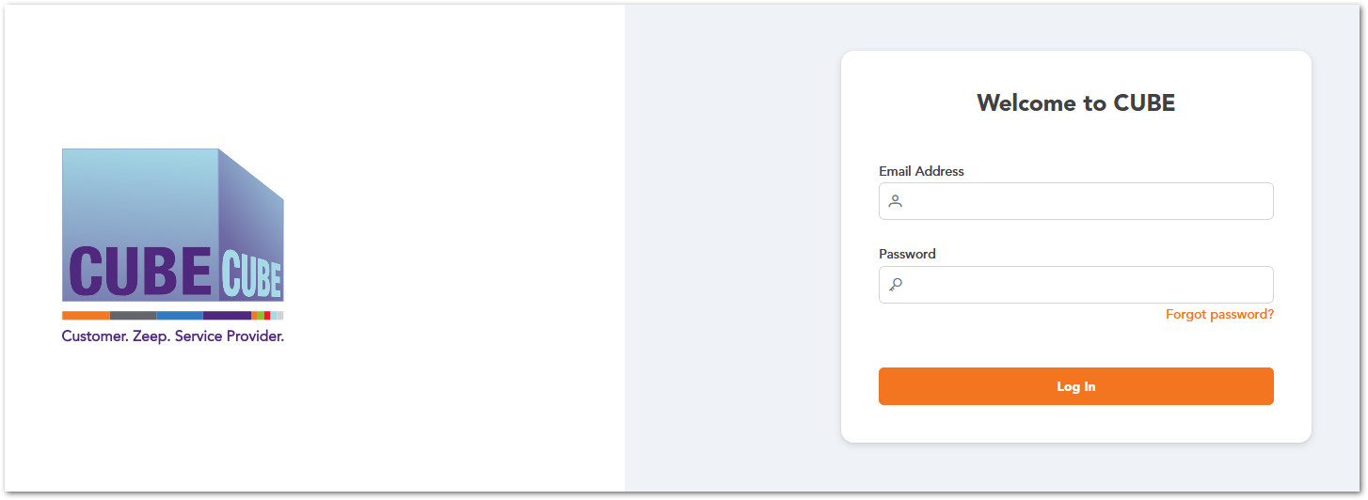

Forgot Password
The Forgot Password option allows users to recover access to their CUBE account if they are unable to log in due to a forgotten password. When this option is selected, the system prompts the user to enter the email address associated with their account. After submitting the request, the system sends a password recovery email containing instructions to reset the password.
Password Recovery Process
- On the Login Page, click Forgot Password.
- Enter the email address associated with your CUBE account.
- Click Send Recovery Mail.
- Check your email inbox for the password recovery message.
- Follow the instructions provided in the email to reset your password.
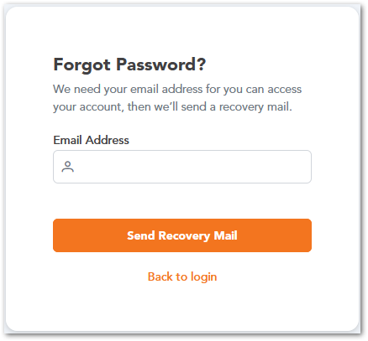
After completing the password reset process, the user can return to the Login Page and access the CUBE platform using the newly created password.

Dashboardz Section
The Dashboardz section provides access to the dashboards available in CUBE. Each dashboard is designed for a specific operational role or area, such as PSP Specialist, Service Provider Summary, SPM Specialist, Service Provider Team Lead, and Tonnage.
Dashboards provide a consolidated view of key indicators, workload items, alerts, and performance information. Depending on the selected dashboard, users can review provider activity, documentation status, accounting inquiries, ticket workload, revenue information, or product performance from a single page.
At the top of each dashboard, users may see the page title, current date, greeting message, view controls, and filters. These controls allow users to adjust the displayed information based on the selected dashboard, role, or view.

PSP Specialist
The PSP Specialist dashboard provides a consolidated view of provider-related activity, performance, compliance, revenue, and ticket workload. This dashboard helps PSP Specialists monitor assigned providers, identify items that require attention, review documentation alerts, and track key operational indicators from a single landing page.

PSP Performance
The PSP Performance section displays win-versus-loss performance by product. Each product includes a circular win-rate chart and a count of wins and losses. This allows users to quickly compare performance across different product categories, such as Toilets, Roll-offs, Containers, and Fencing. Users can change the reporting period using the available filters, including Daily, Weekly, Monthly, Quarterly, and YTD.
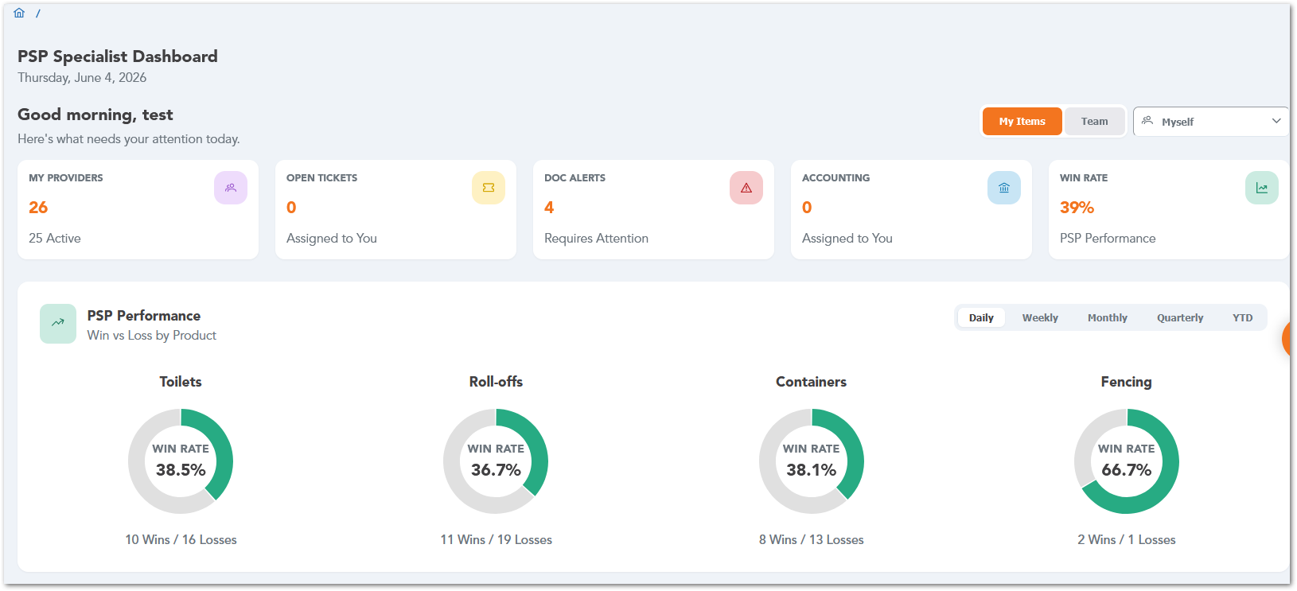

PSP Status Overview
The PSP Status Overview section summarizes provider verification and authorization status. It displays the total number of PSPs, how many are verified, how many are authorized, and how many are not authorized.
The section also includes progress bars for verification status and authorization status. These bars provide a quick visual summary of provider compliance, helping users identify whether provider records are complete and authorized for use.
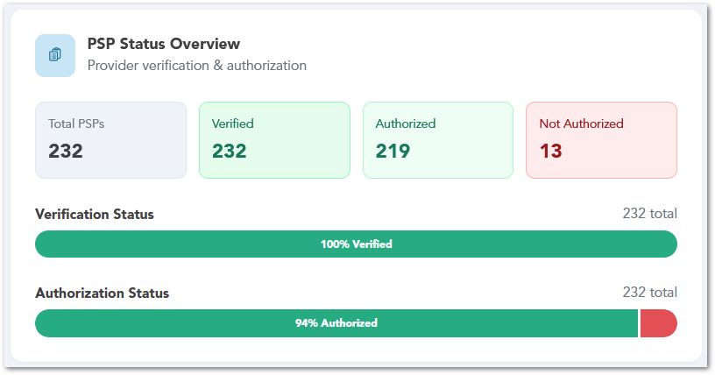

Accounting Inquiries
The Accounting Inquiries section shows the top Service Providers by inquiry volume. The bar chart helps users identify which Service Providers have the highest number of accounting-related inquiries.
This section is useful for reviewing Service Provider activity and identifying providers that may require additional accounting follow-up.
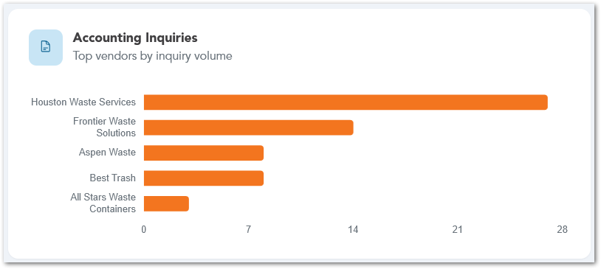

Inquiry Status Breakdown
The Inquiry Status Breakdown section displays accounting inquiries by status. Each status is represented in a horizontal bar chart, allowing users to compare the number of inquiries in each stage.
This section helps users understand where accounting inquiries are currently located in the workflow, such as new inquiries, items ready for approval, research items, lead approval items, or sales review items.
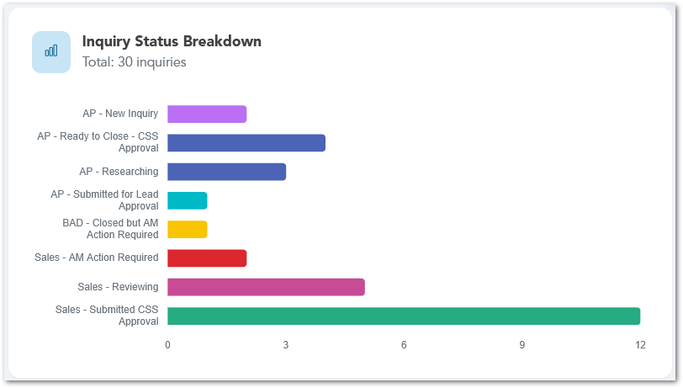

PSP Revenue
The PSP Revenue section provides a revenue overview for the selected period. Users can switch between Weekly, Monthly, Quarterly, and YTD views to review revenue performance over time.
This section displays the PSP contribution to revenue, the revenue amount for the selected period, and a revenue trend chart. It also lists the top providers by revenue, including the number of items and the revenue amount associated with each provider. The Details option allows users to access additional revenue information when available.
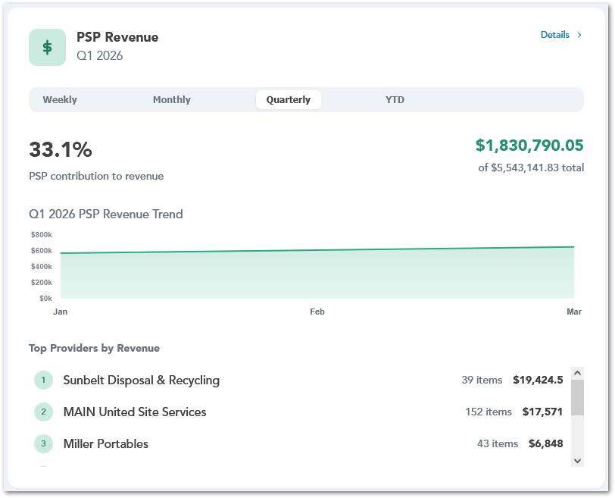

My Providers
The My Providers section displays the providers assigned to the current user. It shows a summary of active providers, providers with issues, and providers with document risk.
Each provider entry includes the provider name, current status, and recent activity information. Users can use this section to monitor their assigned providers and quickly identify providers that may require attention. The View All option allows users to open the complete provider list when additional review is needed.
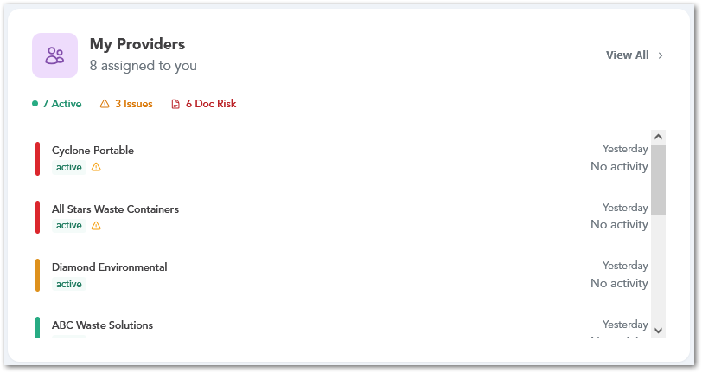

Documentation Alerts
The Documentation Alerts section displays COI and W9 compliance status for providers. It summarizes missing, expired, and expiring-soon documents.
Below the summary cards, the section lists providers requiring attention and identifies the specific documentation issue, such as an expired COI or missing W9. This helps users quickly prioritize providers that need doc follow-up. The View All option allows users to review the full list of documentation alerts.
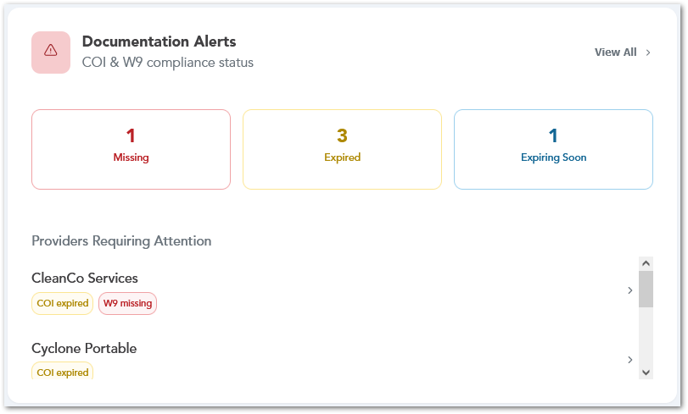

SPM Tickets
The SPM Tickets section provides an overview of the Service Provider management ticket queue. It displays the number of open tickets assigned to the current user and the total number of open tickets for the team.
The section also includes a status breakdown for tickets, such as pending, assigned, in progress, submitted for approval, and stalled. This helps users understand the current state of the SPM ticket queue and identify whether any tickets require follow-up. The View All option allows users to open the complete ticket list.
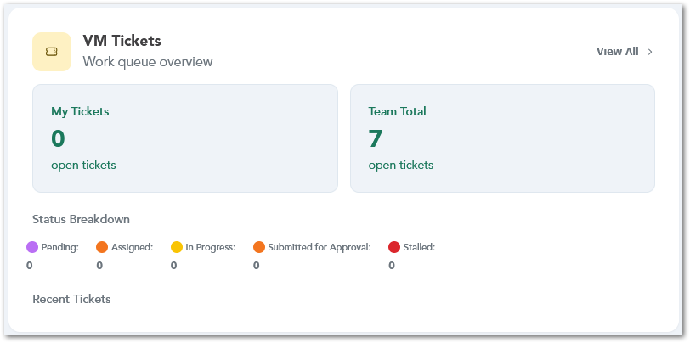

Service Provider Summary
The Service Provider Summary dashboard provides a high-level overview of service provider activity, lifecycle status, compliance risk, inquiry volume, revenue distribution, and PSP performance. This dashboard is intended to help users review provider-related metrics across the organization, identify areas that may require attention, and compare provider performance from a single summary page.

Service Provider Snapshot
The Service Provider Snapshot displays key totals related to service providers, including total service providers, total PSPs, authorized providers, verified providers, active providers, active compliance issues, active stock notices, and providers bought out. These summary cards provide a quick view of the current provider population and its overall status.
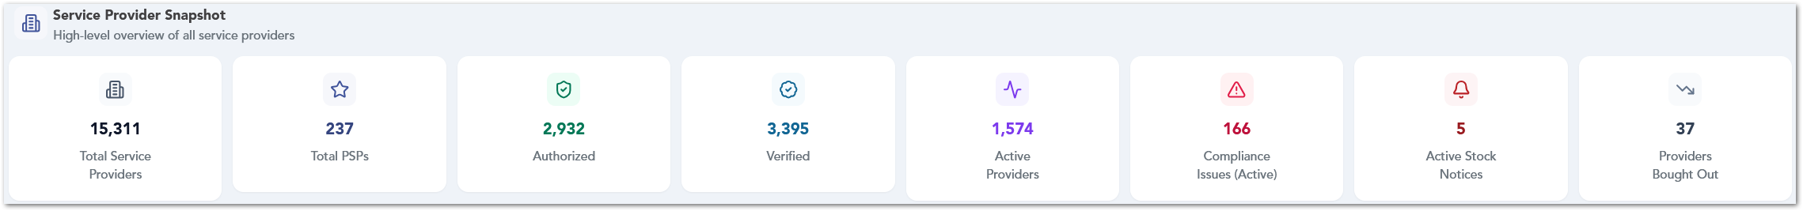

Provider Lifecycle Distribution
The Provider Lifecycle Distribution chart shows service providers grouped by lifecycle status, such as Draft, Pending Verification, Authorized, Verified, and DNU. This chart helps users understand how providers are distributed across different stages of the provider’s lifecycle.
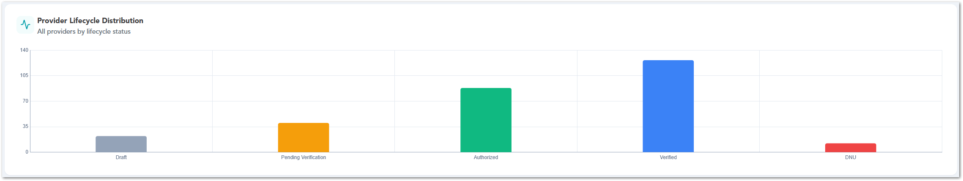

PSP by Specialist
The PSP by Specialist chart shows the number of providers assigned to each PSP Specialist. This helps users compare provider assignment volume across specialists and identify workload distribution.
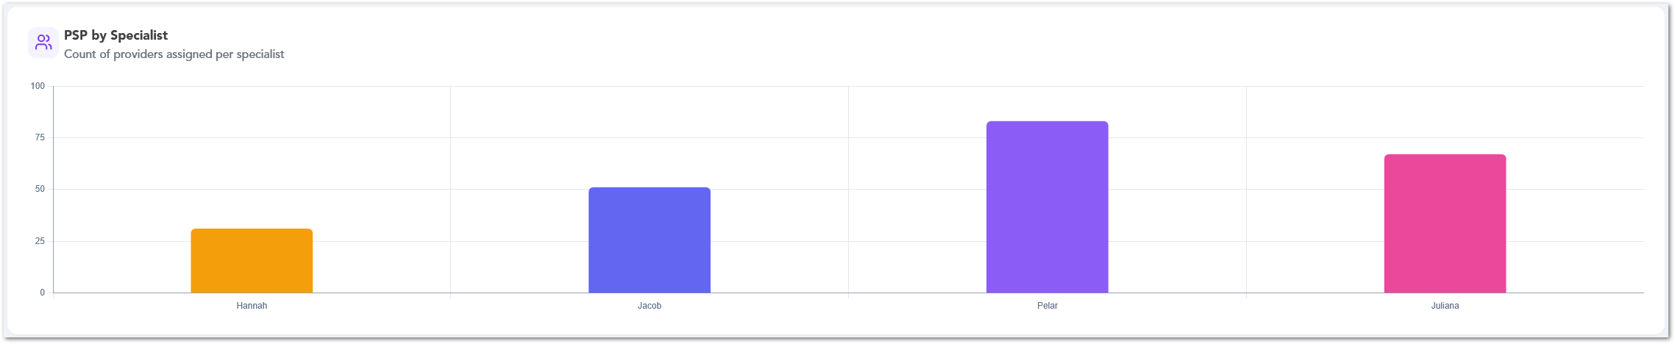

PSP Performance by Product
The PSP Performance by Product area displays win-versus-loss performance across product categories, such as Toilets, Roll-offs, Containers, and Fencing. Users can review win rate percentages and total wins and losses by product, with timeframe filters available for weekly, monthly, quarterly, and YTD views.
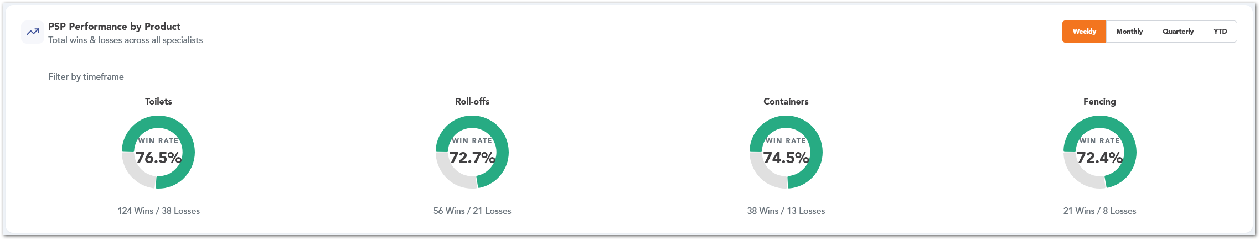

Compliance Risk
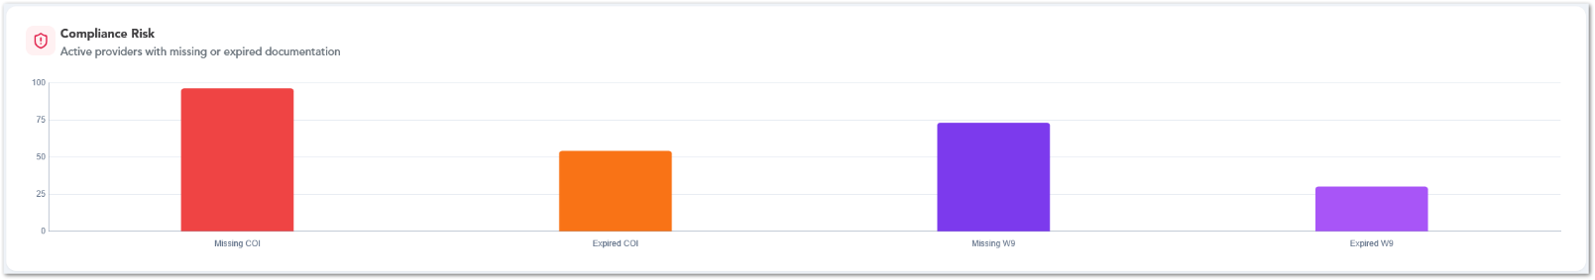
The Compliance Risk chart shows active providers with missing or expired documentation, such as missing COI, expired COI, missing W9, or expired W9. This section helps users identify documentation risks that may require follow-up.

Accounting Inquiries
The Accounting Inquiries section provides visibility into open accounting inquiry across service providers and specialists. It includes two charts: one showing the providers with the highest inquiry volume, and another showing how inquiries are distributed by workflow status. Together, these charts help users identify high-volume providers and understand where inquiries are currently positioned in the review or approval process.
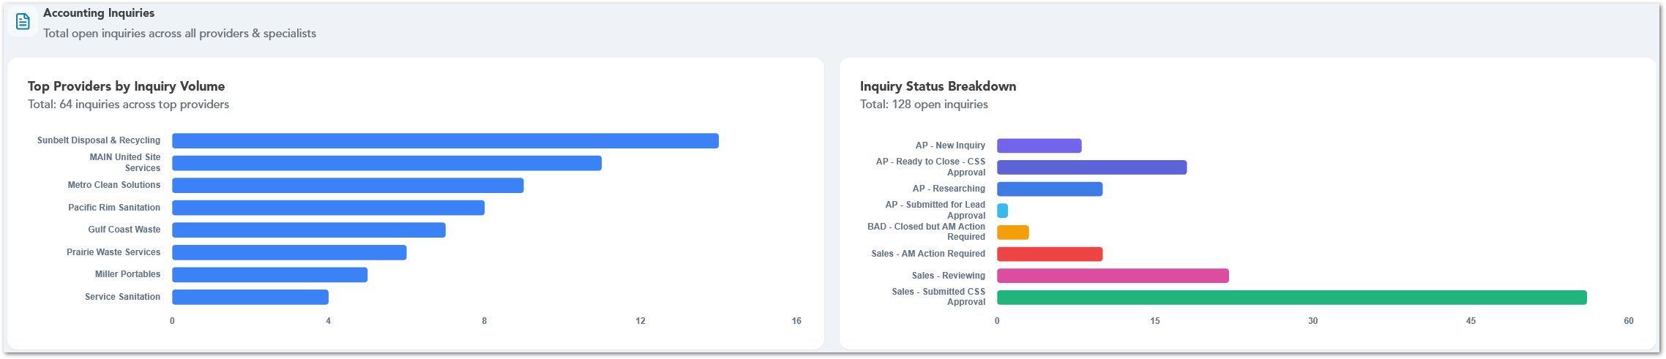

Revenue by Provider Type
The Revenue by Provider Type section compares PSP and non-PSP billed revenue. It displays year-to-date revenue totals, PSP revenue, non-PSP revenue, PSP revenue share, and monthly revenue distribution. This section helps users understand how PSP revenue contributes to overall billed revenue.
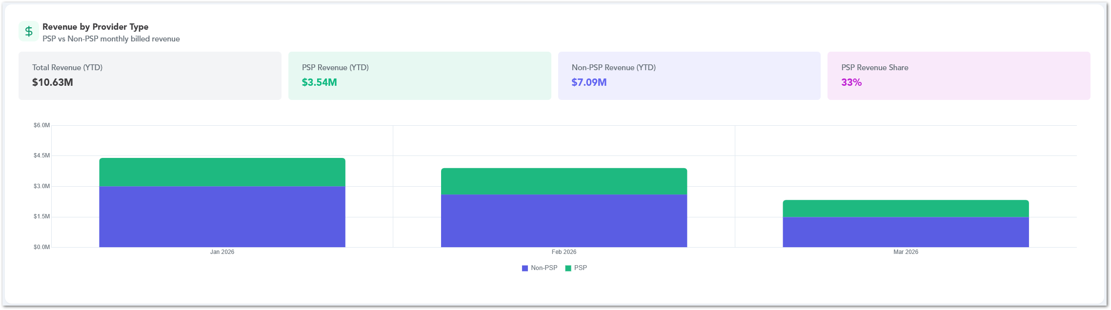

SPM Specialist Dashboard
The SPM Specialist dashboard provides a focused view of ticket workload, compliance risk, provider lifecycle status, and operational readiness. This dashboard helps SPM Specialists monitor open and aging tickets, identify critical documentation issues, review COI upload activity, and track provider readiness indicators from a single page.

Ticket Summary
The Ticket Summary cards provide a quick overview of the current ticket workload. Users can review the number of open tickets, critical tickets, tickets older than seven days, and tickets older than thirty days. These cards help users quickly identify workload volume and aging items that may require follow-up.

Ticket Aging Buckets
The Ticket Aging Buckets chart groups tickets by age range, such as 0-7 days, 8-14 days, 15-30 days, and 30+ days. This chart helps users understand how long tickets have been open and identify older tickets that may need attention.
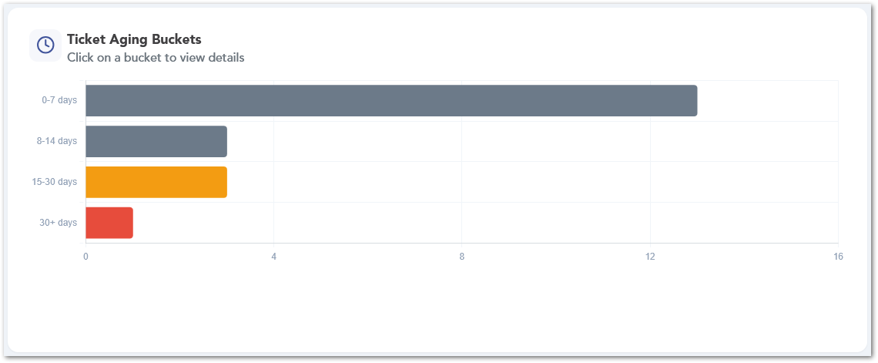

Average Resolution Time
The Average Resolution Time chart shows ticket resolution performance by ticket category. This allows users to compare how long different types of tickets typically take to resolve and identify categories that may require process review.
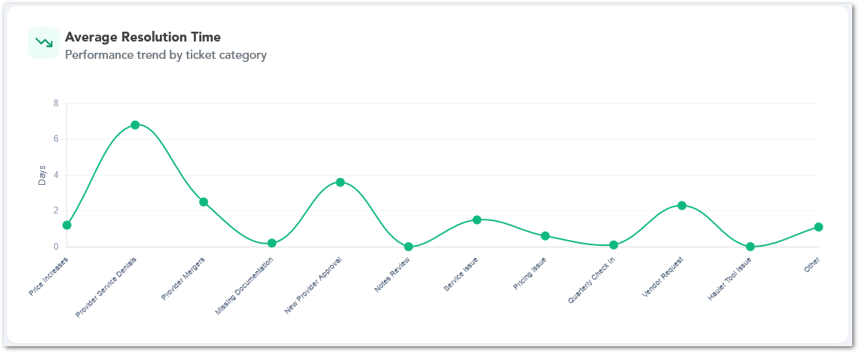

Compliance Risk
The Compliance Risk section displays provider documentation issues, including missing COI, expired COI, missing W9, expired W9, and COI documents expiring within 30 days. This section helps users prioritize documentation follow-up and reduce compliance risk.

COI Expiration Timeline
The COI Expiration Timeline chart shows upcoming COI expirations by month. Users can select a month to review providers with expiring documentation and plan follow-up before documents become expired.
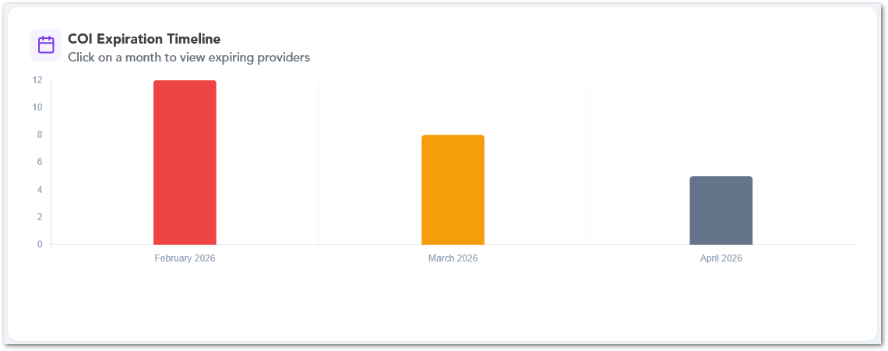

COI Upload Activity
The COI Upload Activity chart shows COI uploads by team members across the selected timeframe. Users can switch between Today, Weekly, Monthly, Quarterly, and YTD views to review upload activity and compare team contribution.
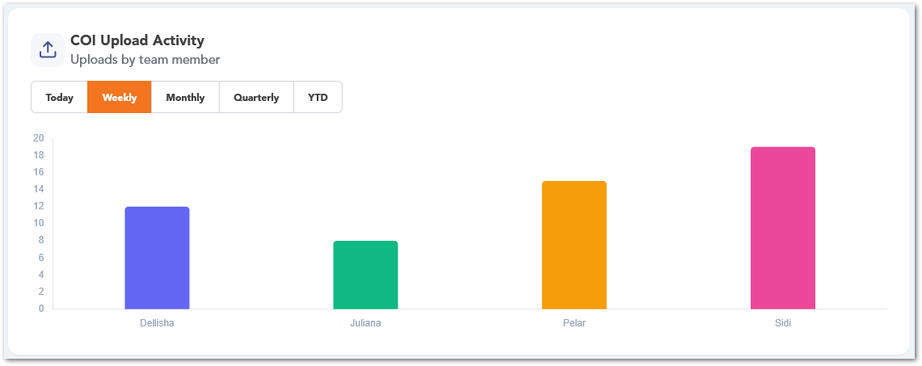

Provider Lifecycle Distribution
The Provider Lifecycle Distribution chart shows providers grouped by lifecycle status, such as Draft, Pending Verification, Authorized, Verified, and DNU. This helps users understand how providers are distributed across key lifecycle stages.
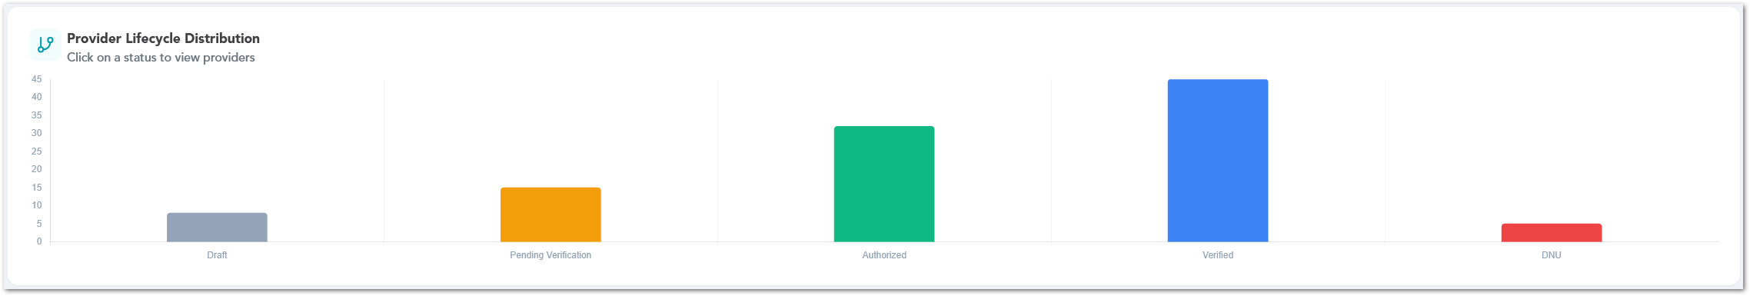

Operational Readiness
The Operational Readiness section highlights provider records that may require operational follow-up, such as providers with active stock notices, missing operating hours, incomplete contact data, or providers bought out. These cards help users identify readiness gaps that may affect provider usage or service coordination.

Service Provider Team Lead Dashboard
The Service Provider Team Lead dashboard provides team-level visibility into PSP assignments, approvals, sales performance, accounting inquiries, documentation gaps, and event-related follow-up work. This dashboard helps team leads monitor specialist workload, compare performance across team members, and identify provider-related items that require coordination or outreach.

Team Members
The Team Members section displays the members included in the team view, along with their names and roles. This provides context for the dashboard metrics and helps users understand which team members are represented in the performance and workload sections.
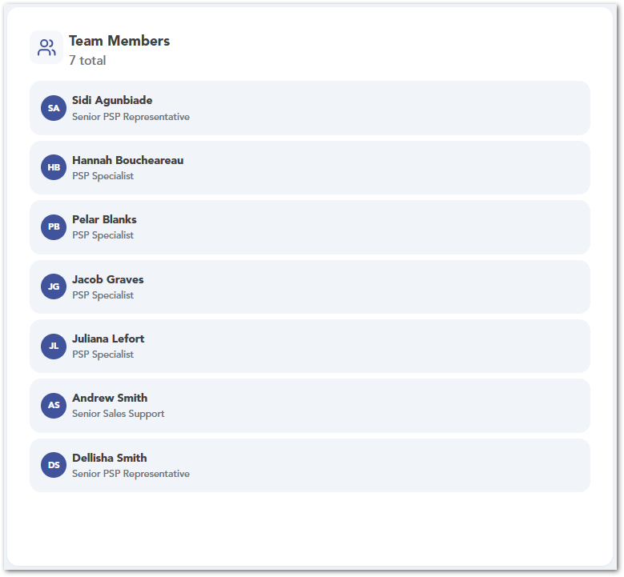

PSP Specialists Overview
The PSP Specialist Overview section summarizes provider assignments and verification status by specialists. It shows each specialist’s total PSP count, verified providers, and authorized providers, allowing team leads to compare workload and provider readiness across the team.
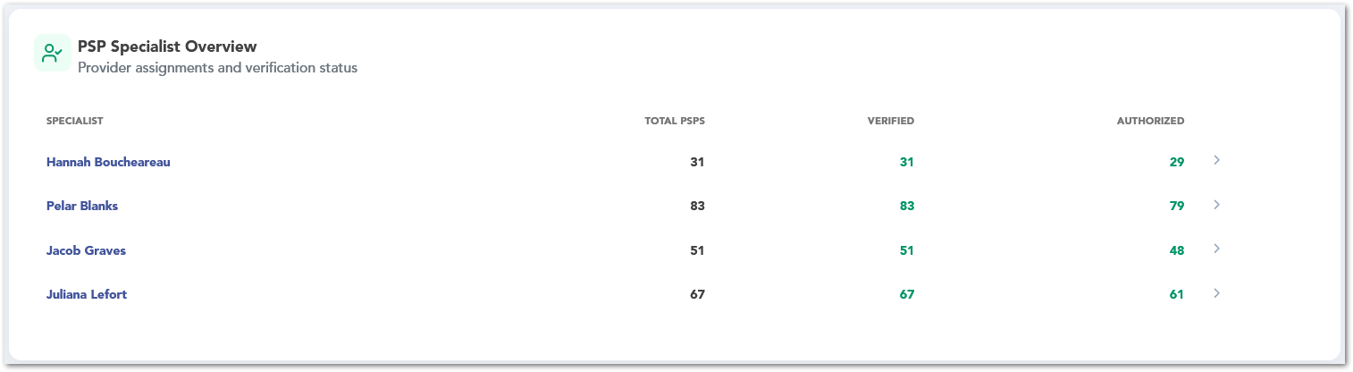

Approved PSPs and Monthly Approvals
The Approved PSPs card displays the year-to-date number of approved PSPs. The Monthly Approvals chart shows approval activity by month, helping team leads monitor approval trends over time.
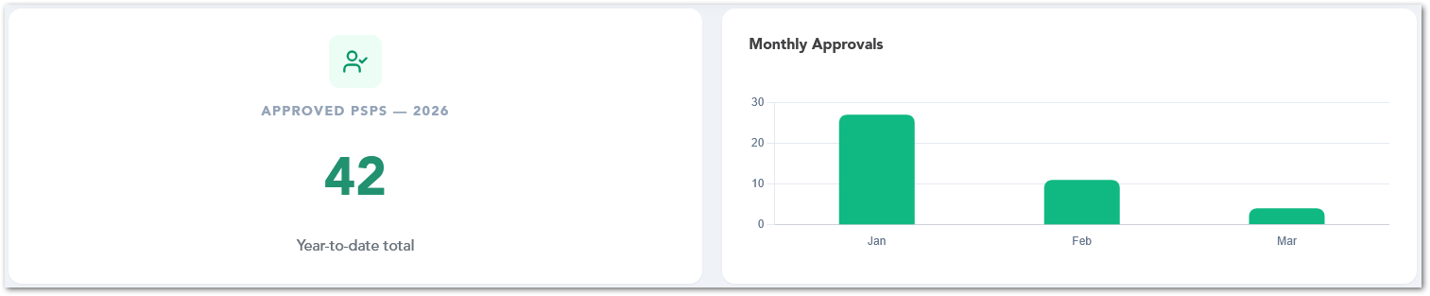

PSP Sales Win Rate Summary
The PSP Sales Win Rate Summary compare win rate percentages by product type and specialist. Users can review performance across product categories such as Toilets, Roll-offs, Containers, and Fencing, and switch between Weekly, Monthly, Quarterly, and YTD views.
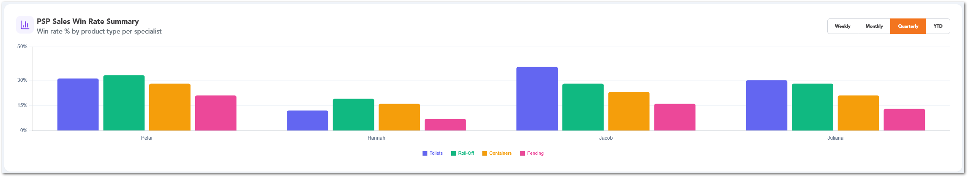

Open Accounting Inquiries by PSP Specialist
The Open Accounting Inquiries by PSP Specialist chart shows the current number of open accounting inquiries assigned to each specialist. This helps team leads identify inquiry workload distribution and determine where follow-up or support may be needed.
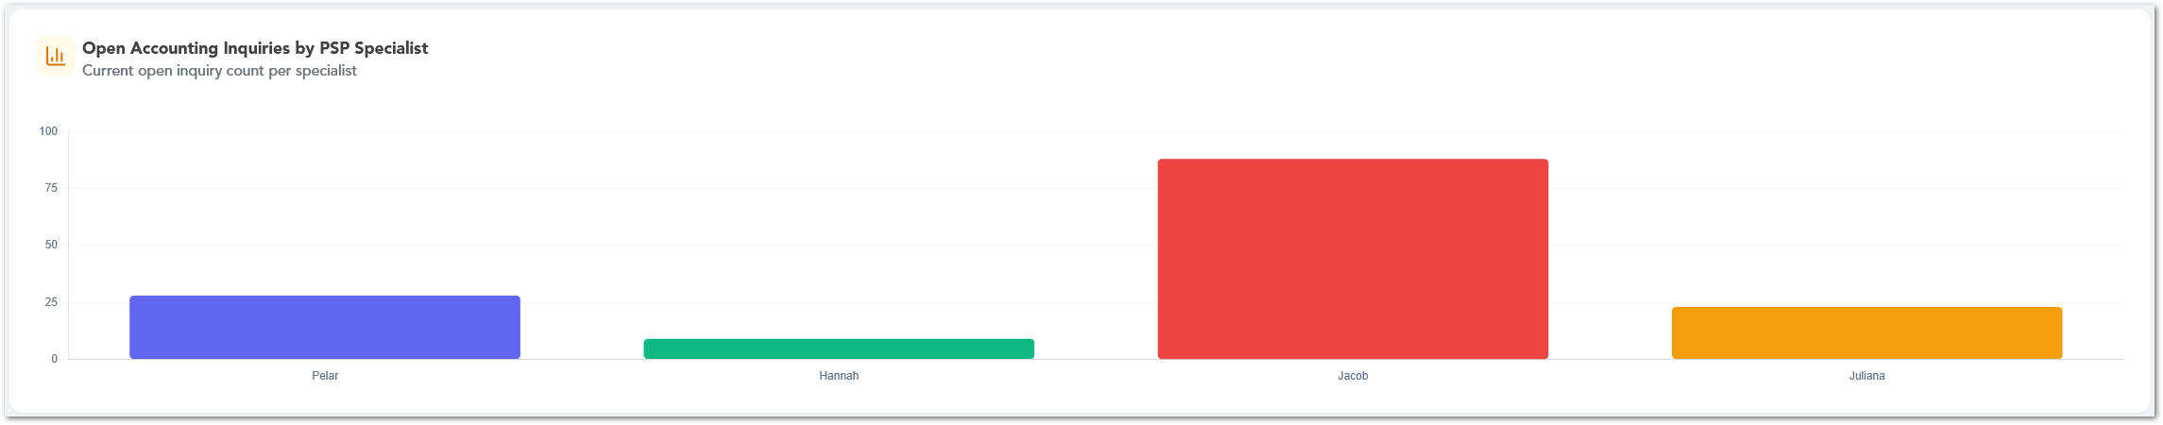

Compliance / Documentation
The Compliance / Documentation section highlights providers with missing documentation that may require outreach. It includes a total count of active providers missing documentation and a provider type breakdown, helping team leads identify documentation risk by provider category.
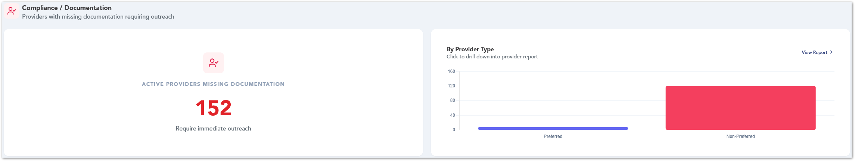

Event Toilet Confirmation
The Event Toilet Confirmation section provides visibility into event-related confirmation requests for the current week. It includes a status overview chart and a follow-up list showing requests that require action, including Service Provider, customer, delivery date, quantity, and current status.
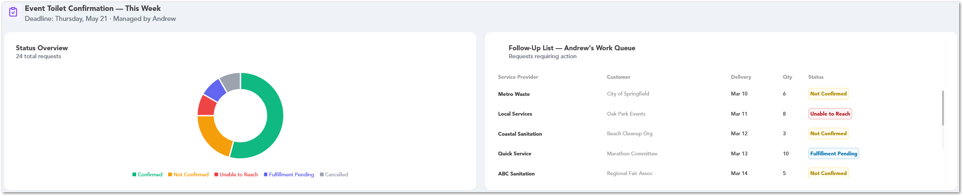

Tonnage
The Tonnage dashboard provides visibility into the event toilet confirmations and final tonnage tracking. This dashboard helps users monitor confirmation progress, identify remaining event toilet follow-ups, review missing final tonnage items, and track who entered final tonnage information.

Event Toilet Confirmation
The Event Toilet Confirmation section summarizes toilet confirmation activity for the current week. It displays key totals such as event toilets this week, unique providers to contact, confirmed items, and remaining confirmations. This section helps users understand the current confirmation workload and track progress toward completion.

Confirmation Progress
The Confirmation Progress section shows the percentage of completed confirmations against the total confirmation requirement. It separates confirmed and remaining items so users can quickly identify how much work has been completed and how much still requires follow-up.
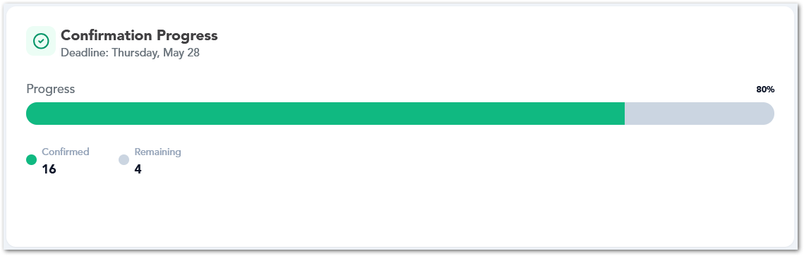

Status Breakdown
The Status Breakdown chart displays event toilet confirmations by status, such as Confirmed, Not Confirmed, Unable to Reach, Fulfillment Pending, or Cancelled. This helps users understand the current state of event confirmations and identify where follow-up may be required.
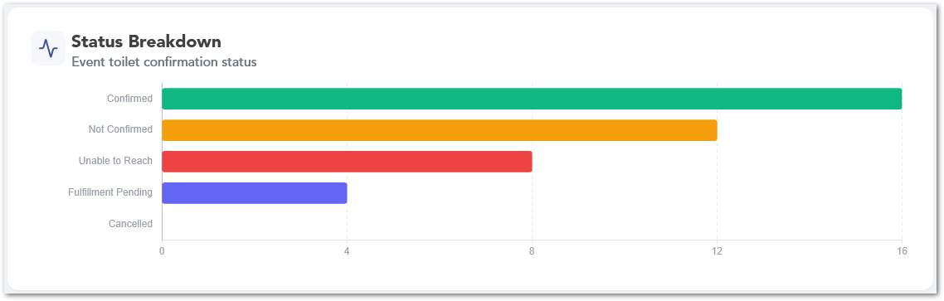

Tonnage Overview
The Tonnage Overview section provides a summary of final tonnage completion. It highlights the number of completed services still waiting for final tonnage, the overall completion rate, and any backlog indicators. Users can also access related actions, such as opening Rossum or Invoices, when available.
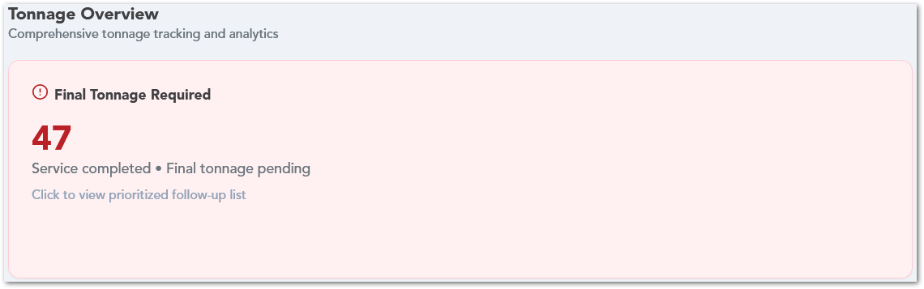

Completion Rate
The Completion Rate card shows the percentage of tickets that already have final tonnage entered. It also displays the number of completed tickets against the total ticket count and may show a trend indicator or warning message when the completion rate is dropping or a backlog is forming.
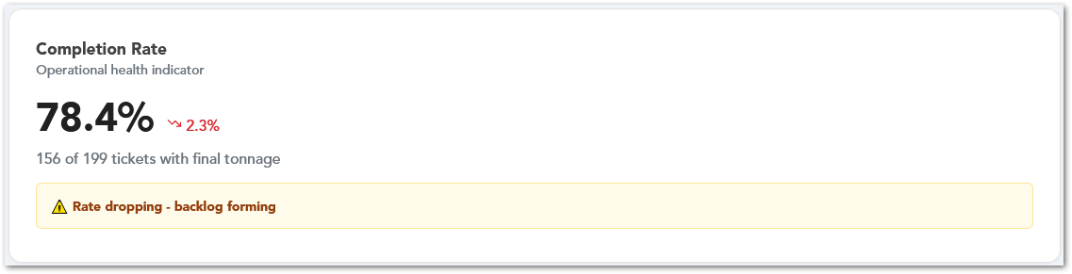

Missing Tonnage - Aging Buckets
The Missing Tonnage - Aging Buckets chart groups missing final tonnage items by age based on the service end date. This helps users prioritize older pending items and identify whether the missing tonnage backlog is increasing.
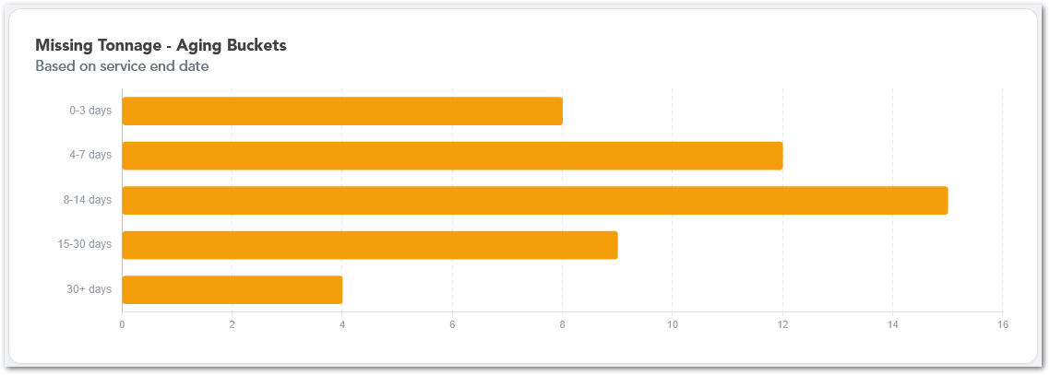

Top Providers Missing Tonnage
The Top Providers Missing Tonnage chart shows which providers have the highest number of missing final tonnage items. This view helps users prioritize follow-up by provider.
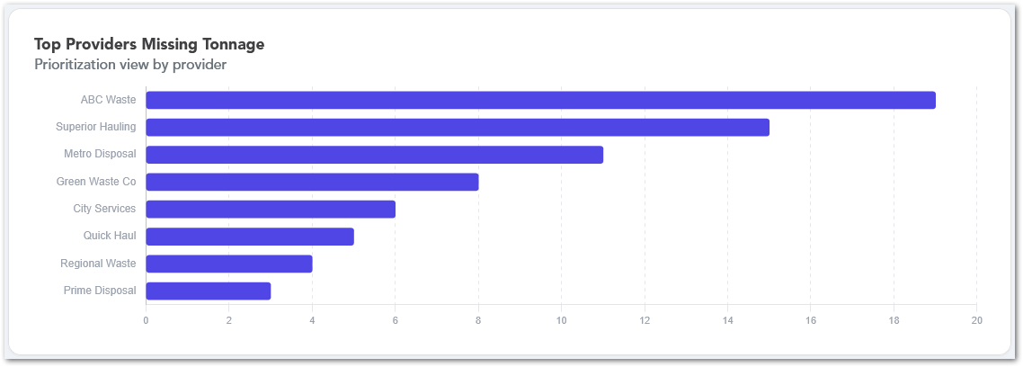

Tonnage Inputted By
The Tonnage Inputted By chart shows who entered final tonnage and when. Users can switch between timeframes, such as Today, This Week, This Month, This Quarter, and YTD, to review tonnage entry activity by user or source.
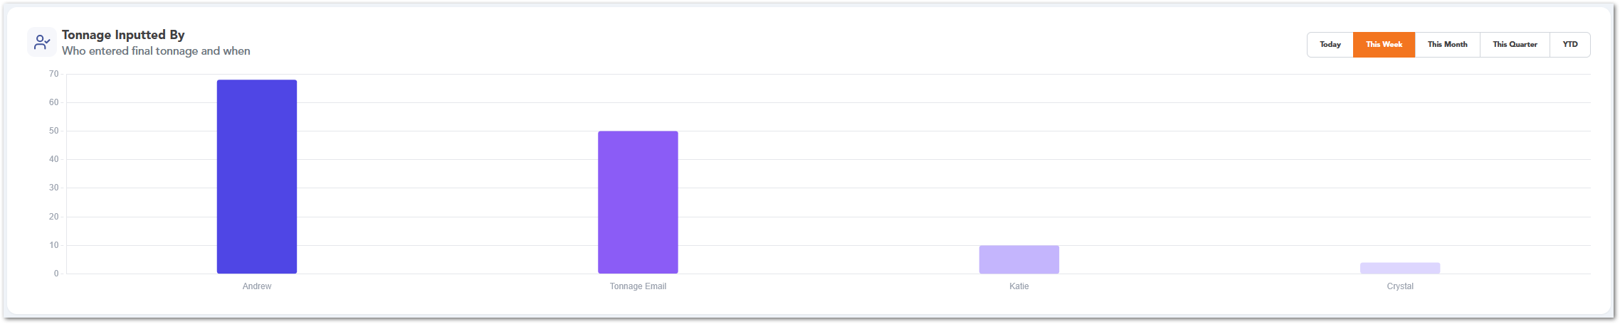

Customerz section
The Customerz section centralizes all customer-related information and operations within the CUBE platform. It allows users to manage customer profiles, contacts, service locations, and financial configurations such as billing preferences and transactions. This section serves as the foundation for linking customers to services, sites, and operational activities. It ensures accurate customer data management across the system.

Customers
This module displays a list of all customer records with key details such as name, contact information, and company. Users can search, filter, and manage records, as well as create new customers. This is the main entry point for customer management.
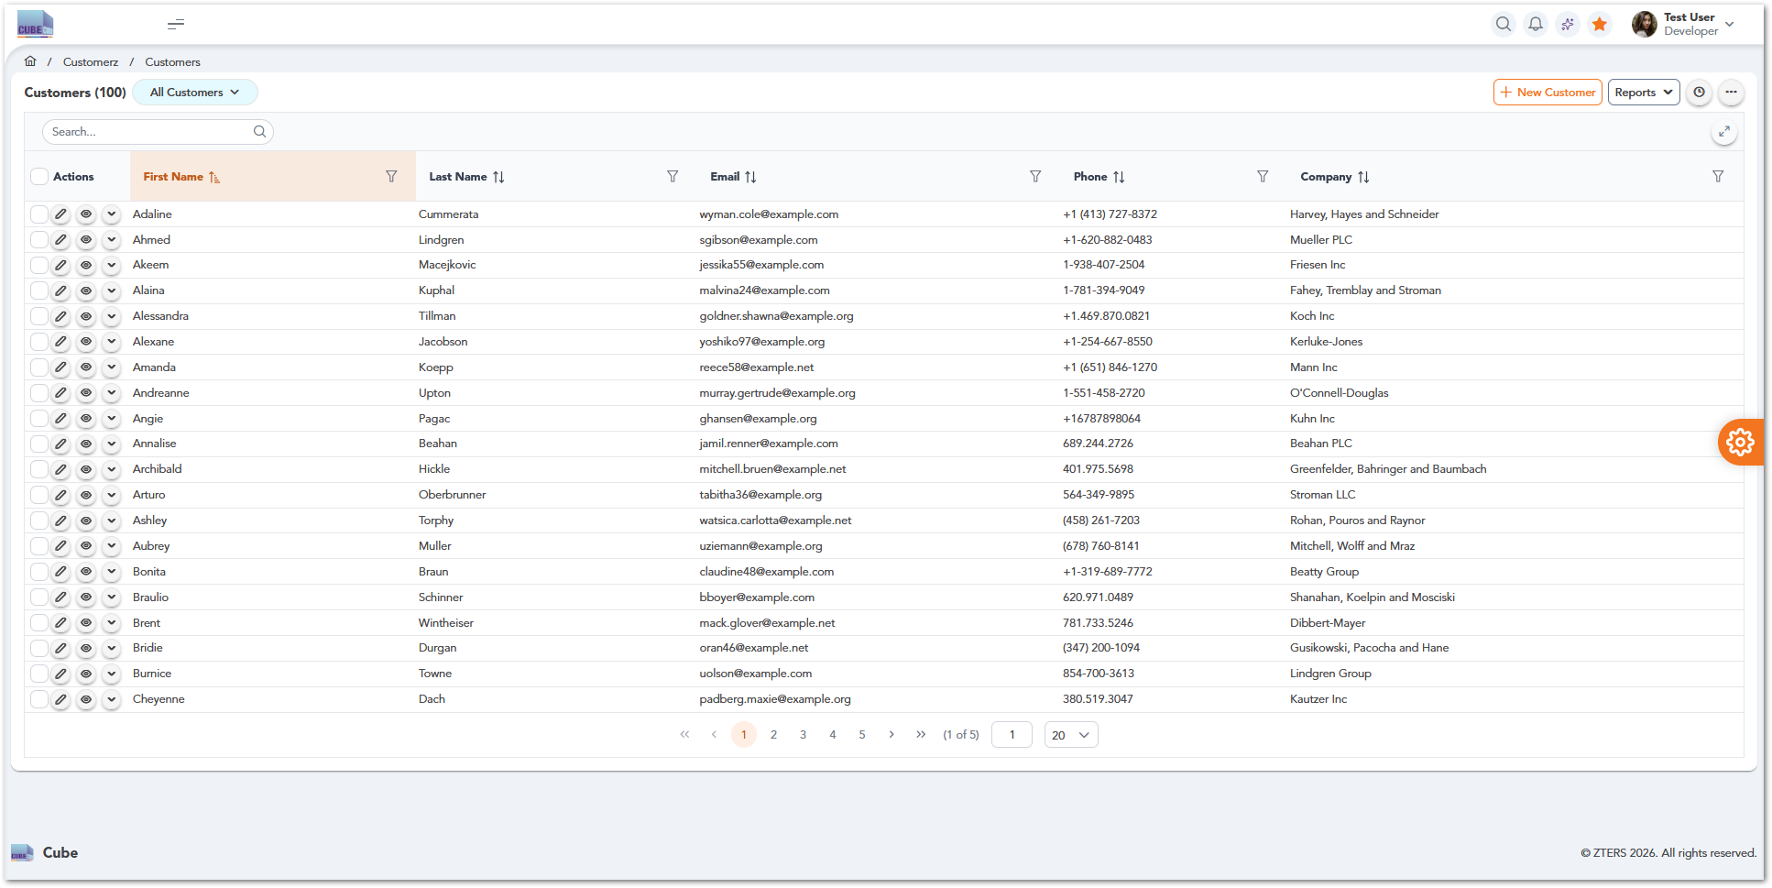

Customer Contacts
This module manages individual contacts associated with each customer account. This section is expected to store contact details such as names, roles, emails, and phone numbers, enabling effective communication and coordination with customer stakeholders. Contacts are typically linked to specific customer records.

Sites
This module manages service locations associated with customers. This section allows users to organize and track where services are delivered. It ensures operations are tied to the correct physical location.

Reviews
This module provides access to customer feedback and service evaluations. This section helps monitor service quality and identify improvement areas. It supports visibility in customer satisfaction.

CC Transactions
This module tracks credit card transactions linked to customer accounts. This includes payment activity and transaction status. It supports financial tracking and transparency.

Credit Limit Requests
This module manages requests related to customer credit limits. Users can review, approve, or update credit capacity. It supports financial control and risk management.

Accounting Inquiries
This module handles billing-related questions and financial issues from customers. This section supports tracking and resolving accounting concerns. It improves coordination between teams.

Billing Preferences
This module defines how customers are billed, including invoicing methods and payment preferences. This ensures billing aligns with customer agreements. It supports flexible financial operations.

Salez section
The Salez section focuses on managing the commercial and transactional aspects of the platform. It includes tools for handling products, service tickets, line items, and invoicing processes. Users can track pricing, manage assets, and monitor financial interactions related to sales. This section supports the full lifecycle of service transactions from creation to billing.

Products
This module manages the catalog of products and services available in the system. It allows users to define product details, pricing, and availability. It serves as the foundation for sales and service transactions.

Toilets
Manage portable toilet services, including standard units, specialty options, and servicing schedules.

Roll-offs
Handle temporary dumpster rentals for waste removal, typically used for construction and cleanup projects.

Containers
Manage storage container rentals for on-site storage needs, including delivery, pickup, and duration.

Fencing
Configure temporary fencing solutions for job sites, events, or restricted areas.

Front Loads
Manage scheduled waste collection services using front-load dumpsters for ongoing commercial use.

Equipment Rentals
Handle rentals of additional equipment such as machinery or support tools required for job sites.

Perm Roll-off
Manage permanent roll-off dumpster services for long-term or recurring waste management needs.

Grease Trap
Handle grease trap cleaning and maintenance services, typically for restaurants and commercial kitchens.

Other Services
Capture and manage miscellaneous services that do not fall under standard product categories.

Service Tickets
This module manages service tickets representing customer requests or operational tasks. It allows users to track the lifecycle of a service from creation to completion. It is central to managing service execution.

Line Items
This module manages individual items within service tickets, including quantities, pricing, and service details. It provides a detailed breakdown of services and charges. It ensures accuracy in billing and configuration.

Invoices
This module manages customer invoices, including creation, tracking, and status updates. It allows users to monitor billing and payment activity. It supports the financial lifecycle of transactions.

AP Hub
This module manages accounts payable processes, including Service Provider payments and financial reconciliation. It supports tracking outgoing payments. It ensures financial operations are properly recorded.

Pricing History
This module provides access to historical pricing data for products and services. It allows users to track changes over time. It supports auditing and pricing analysis.

Z Sight Monitors
This module provides visibility into operational and sales metrics through monitoring tools. It allows users to track system performance and activity. It supports data-driven decision-making.

Assets
This module manages assets associated with services, customers, or operations. It allows users to track asset details and assignments. It supports inventory and operational management.

Operationz section
The Operationz section manages the execution and coordination of services within the platform. It includes tools for handling service providers, fulfillment processes, Service Provider interactions, and pricing configurations. Users can track operational activities, manage service availability, and ensure proper service delivery. This section is critical for aligning internal operations with external providers.

Role Select
The Role Select page provides access to the role-based dashboards available within the Operationz module. Users can select the dashboard that matches their operational role, such as Customer Success Supervisor, Account Manager, Business Development Representative, BDR Team Lead, or Client Success Manager.
Each role card includes the role name, the corresponding dashboard name, and an Open Dashboard option. When users select an option, CUBE redirects them to the selected dashboard page within Operationz, where they can review the KPIs, tools, and information relevant to that role.
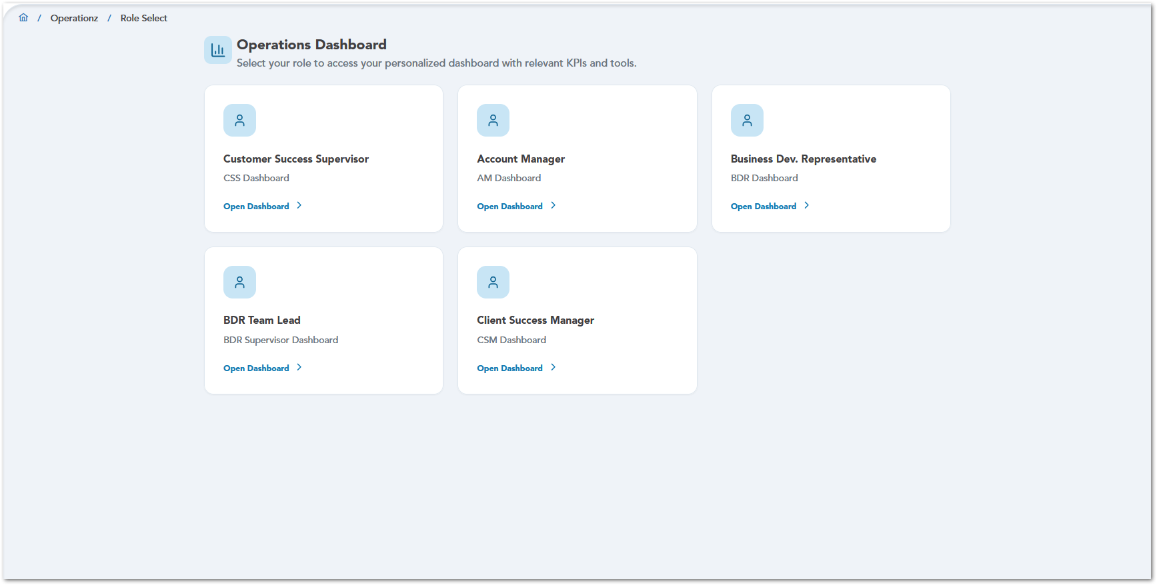

CSS Dashboard
The CSS Dashboard provides Customer Success Supervisors with a team-level view of revenue, customer status, account health, billing workload, accounting inquiries, and task activity. This dashboard helps supervisors monitor team performance, identify customer accounts that may require follow-up, and review operational or financial items that need attention.
Users can use the Team View selector to review dashboard information for the selected team. The dashboard also displays the last refresh time so users can identify when the displayed information was last updated.

CSS Dashboard Summary
The top section of the CSS Dashboard displays summary cards for key team indicators, including team revenue, average close ratio, average margin, and customer status. These cards provide a quick overview of the team’s current performance and customer base before users review the detailed dashboard sections below.
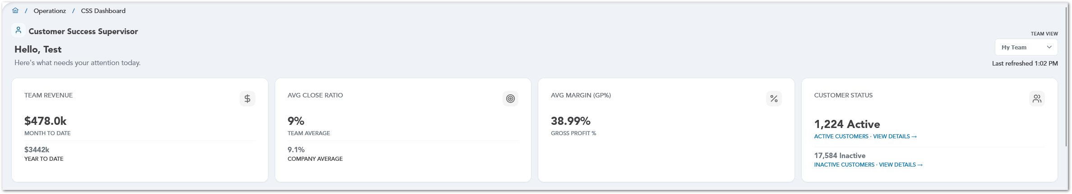

Revenue & Performance
The Revenue & Performance section helps Customer Success Supervisors review team revenue and margin performance. It includes charts for revenue by Account Manager, monthly revenue trends, and margin percentage by Account Manager. These visuals help users compare individual performance, monitor revenue movement over time, and identify margin results across the team.

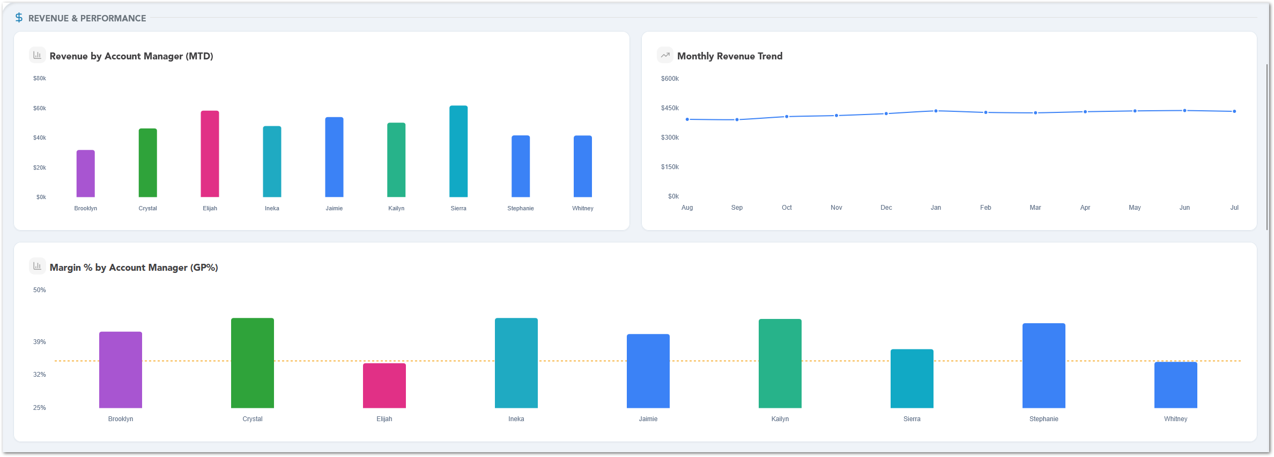

Close Ratio
The Close Ratio section helps Customer Success Supervisors review how effectively calls are being converted into customers. It includes charts that compare close ratio by Account Manager, show team performance against the company average, and break down close ratio by queue type. These visuals help users identify individual and team trends, compare performance across months, and review how different queue types contribute to conversion results.
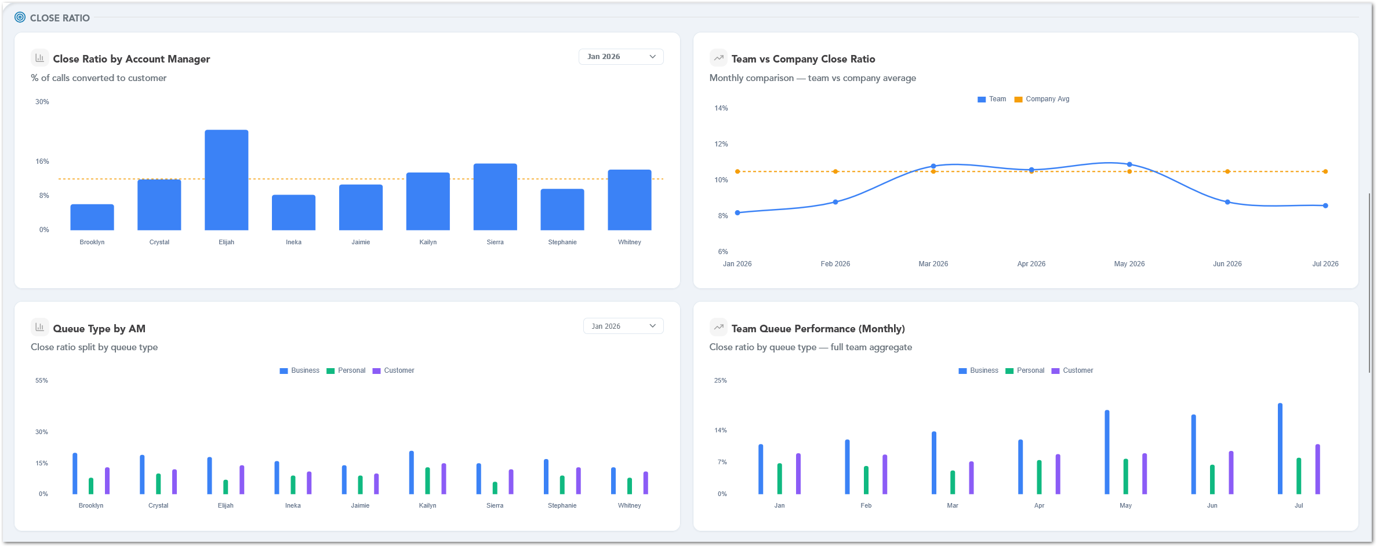

Tasks & Activities
The Tasks & Activities section helps Customer Success Supervisors review completed team activity for the selected period. It includes summary cards for check-ins, delivery follow-ups, removal follow-ups, and good reviews. The charts below provide a breakdown of task completion by Account Manager and show monthly task trends across the full team, helping users compare activity levels and identify how task volume changes over time.

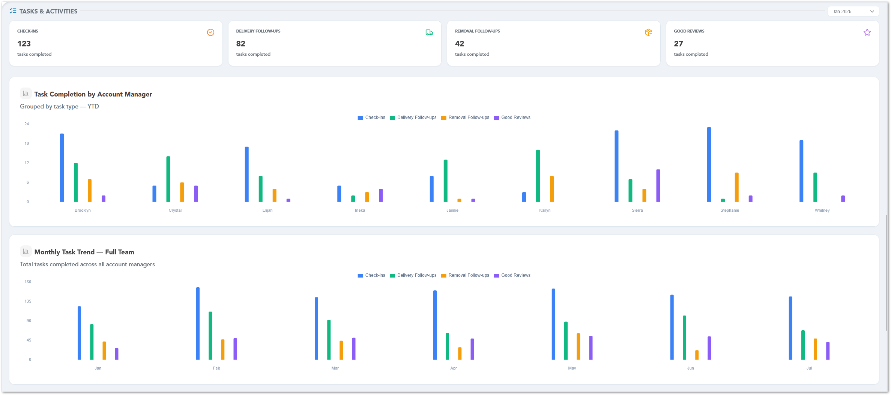

Account Health
The Account Health section highlights customer accounts that may require attention or follow-up. It displays counts for accounts on stop service, accounts that need re-engagement, accounts approaching their credit limit, and overdue accounting inquiries. Each card includes a View accounts option so users can open the related account list and review the affected records.
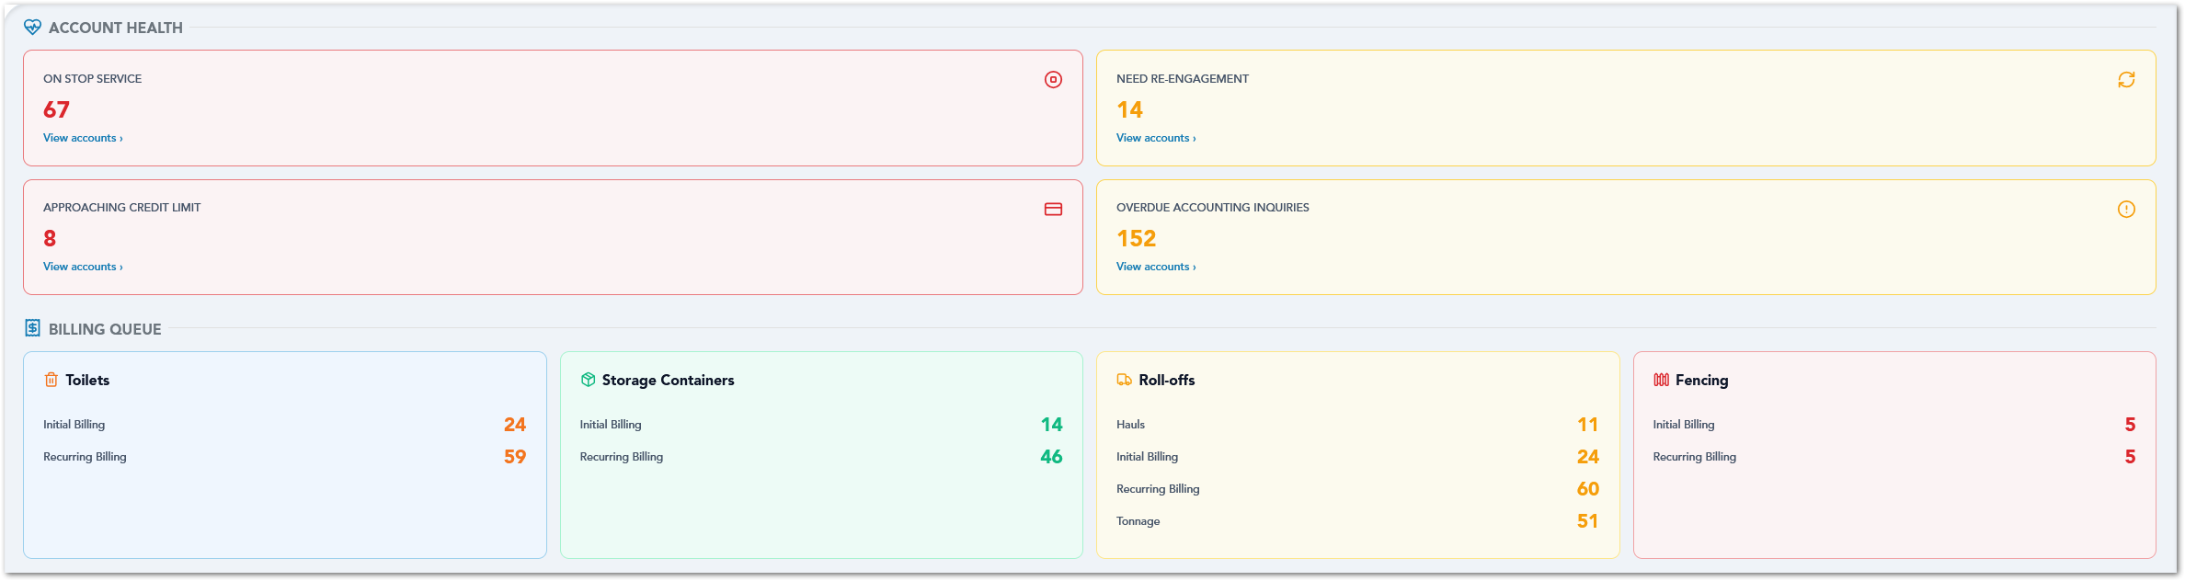

Billing Queue
The Billing Queue section summarizes pending billing items by product type, including Toilets, Storage Containers, Roll-offs, and Fencing. Each card displays the billing categories that require attention, such as initial billing, recurring billing, hauls, or tonnage, along with the current count for each category. This helps users quickly identify where billing follow-up is needed across different service lines.
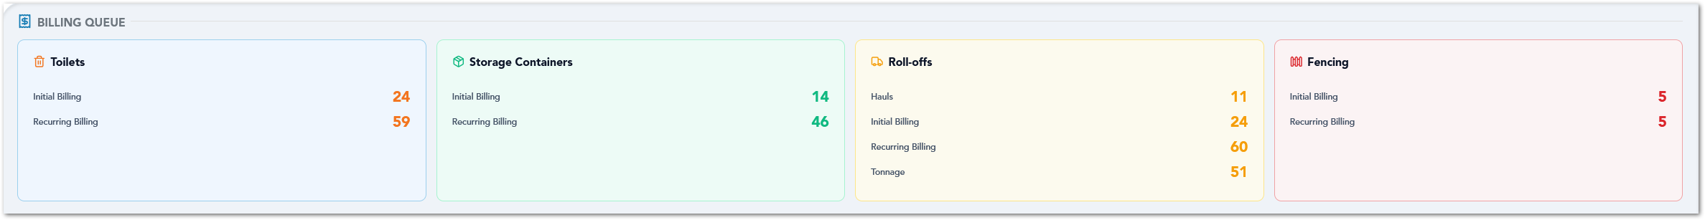

Accounting Inquiries
The Accounting Inquiries section helps Customer Success Supervisors review open accounting inquiries by age. It displays summary cards for inquiries that are 0–30 days, 31–60 days, and 60+ days old, along with the total number of open inquiries. The chart below shows inquiry aging by month created, using color coding to identify newer, aging, and older inquiries. Users can select a card or chart bar to view the related inquiry details.
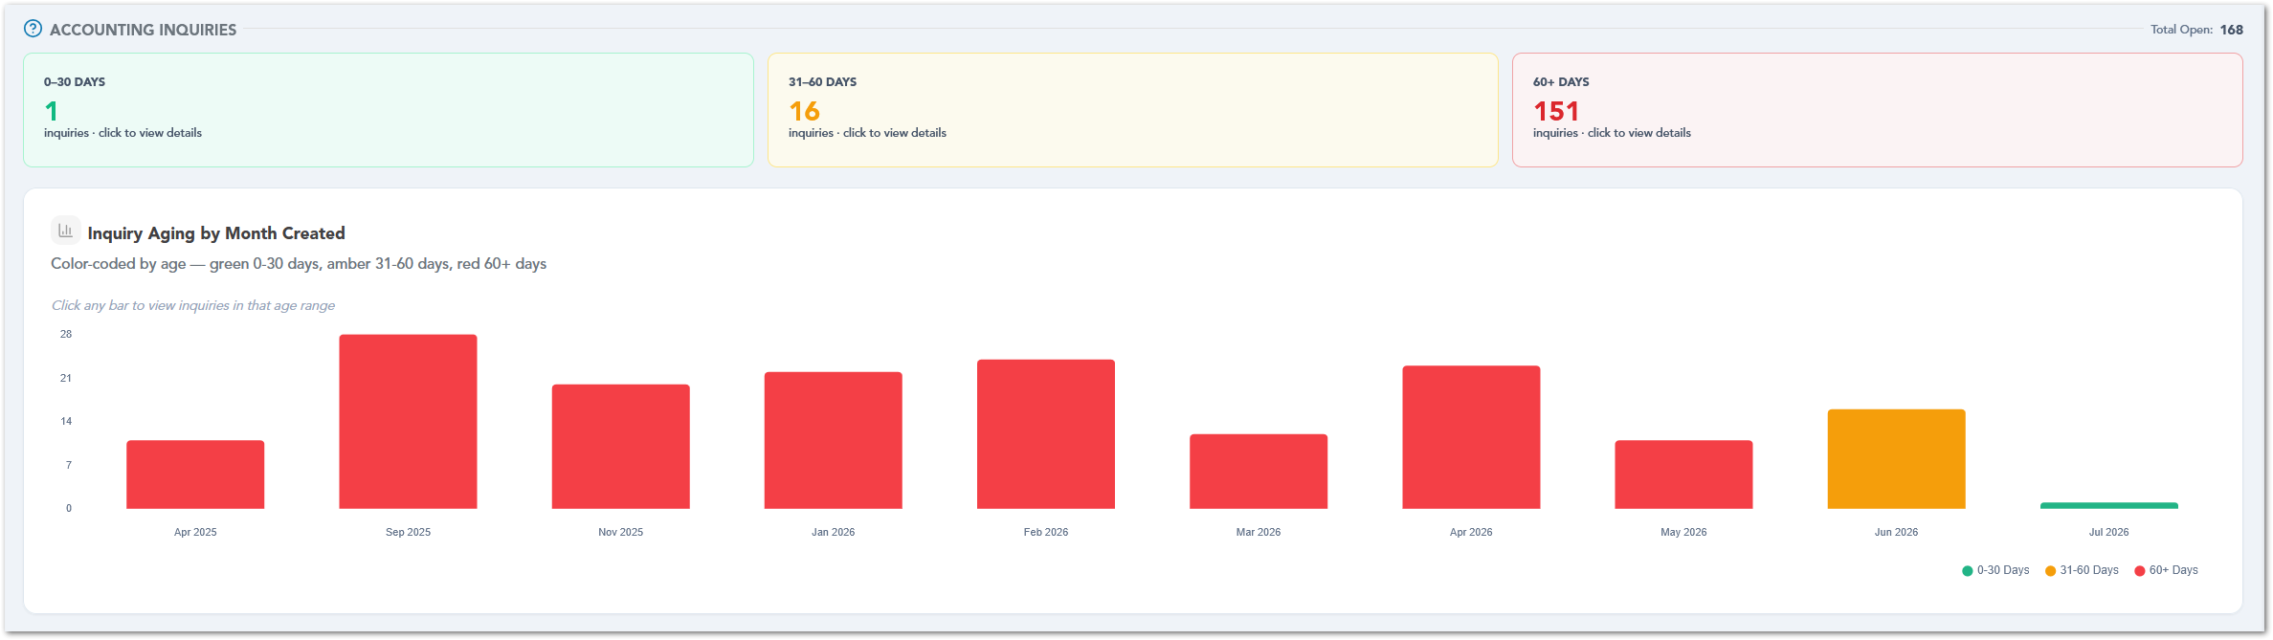

Aging & Financial Health
The Aging & Financial Health section summarizes past-due financial items by aging range and highlights accounts that may require follow-up. It displays aging cards for 0–30 days, 31–60 days, 61–90 days, and 90+ days, including the number of items and past-due amount for each range. The section also shows the total past-due amount, past-due accounts, overpayments, and unapplied credits, with View details options available for reviewing the related records.
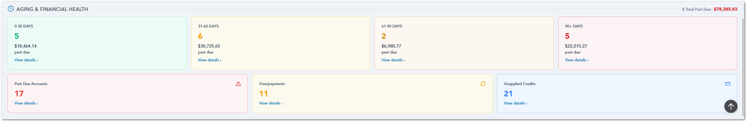

AM Dashboard
The AM Dashboard provides Account Managers with a focused view of their revenue, close ratio, gross profit margin, goal progress, and customer health indicators. This dashboard helps Account Managers monitor their individual performance, compare current results against company averages or targets, and identify customer accounts that may require follow-up.

Dashboard Summary
The top section of the AM Dashboard displays key performance indicators for the Account Manager, including month-to-date revenue, close ratio, and gross profit margin. It also includes a Goal vs Actual chart that compares current revenue performance against defined revenue ranges or targets.
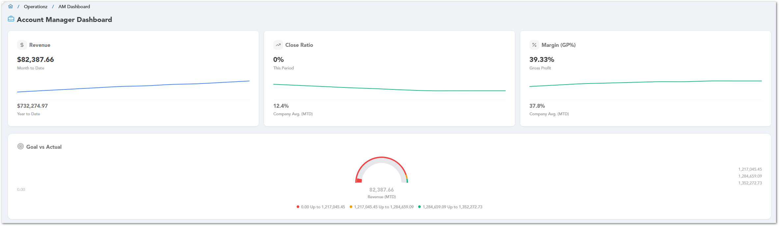

Customer Health
The Customer Health section summarizes the Account Manager’s customer base and highlights accounts that may require attention. It displays active customers, inactive customers, and re-engagement opportunities, with links to view the related account or contact details.

Service Providers
The Service Providers module displays the list of service providers registered in CUBE. Users can search, sort, and filter provider records from the table. Each record shows key provider information such as company name, verification status, DNU status, service provider ID, phone number, address, city, and state. The Actions column allows users to view, edit, select, or access additional options for a provider.
Users can also switch between saved views or reports, create a new service provider, and navigate through the list using the pagination controls at the bottom of the page.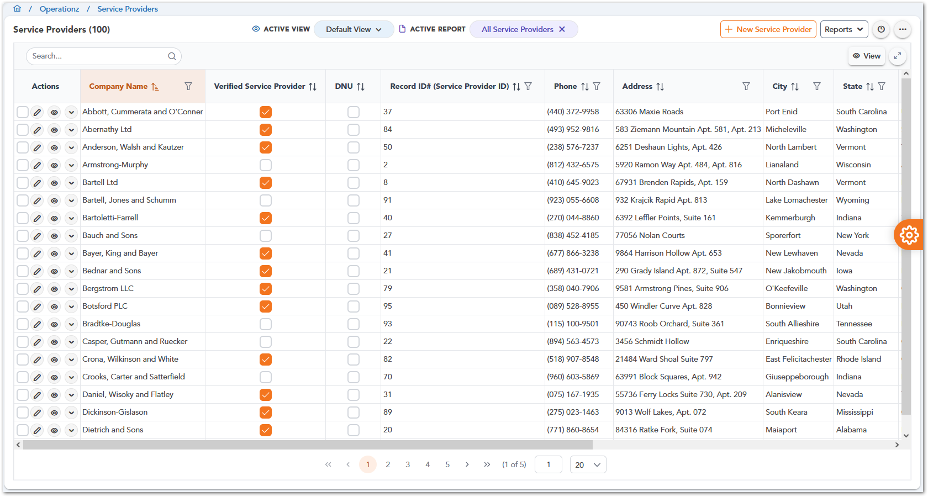
The Actions column provides quick access to the most common record-level options available for each service provider. These options allow users to edit, view, or expand a provider record directly from the table.
Option | Design | Description
Edit |  | Opens the selected service provider record in edit mode so users can update provider information.
View |  | Opens the selected service provider record in read-only mode so users can review the full details without making changes.
Expand / Collapse |  | Displays or hides additional summary information directly within the table row, allowing users to review key provider details without opening the full record.

Service provider summary
In the Service Providers table, users can select the expand/collapse button in the Actions column to expand a provider record. When expanded, the row displays summary information about the selected service provider, such as created and modified dates, last modified user, company name, phone number, insurance expiration date, document status, related notes, and associated services. This allows users to review key provider details without opening the full record.
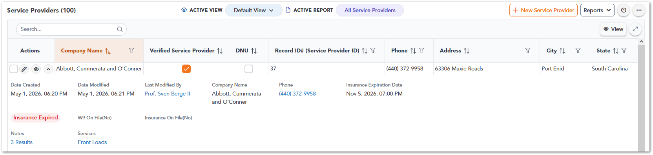

Service provider view
When users select the View icon from the Service Providers table, CUBE opens the selected provider record in read-only view. This page displays a complete overview of:
- Service provider
- Including health status
- Compliance indicators
- Provider details
- Workflow progress
- User information
- Status information
- AI summary
- Business hours
- Related counts
- Approvals
- Open or recent tasks
- Important dates
- Documents
- Contacts
- Services
- Activity timeline.
The left navigation panel allows users to move between related sections of the provider record, such as Contacts, Notes, Tasks, PSP Zones, PSP Pricings, Qualification, COI/W9, Accounting, Inquiries, Services, Fulfillment, Quotes, Reviews, and Ratings. The main overview area groups the most important information into reusable UI blocks so users can review provider status and related activity without switching between multiple pages.
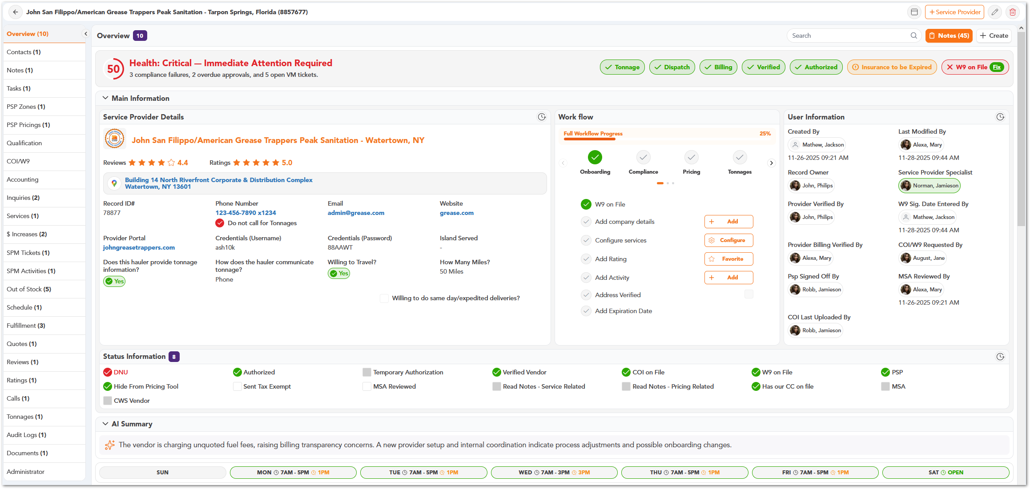
The Approvals & Open/Recent Tasks section displays pending and completed approval items alongside current provider-related tasks. Approvals show request details, decision status, and available actions such as approve or reject. The tasks panel shows assigned work items, due dates, completion status, and quick actions, allowing users to monitor follow-up activities directly from the provider overview.
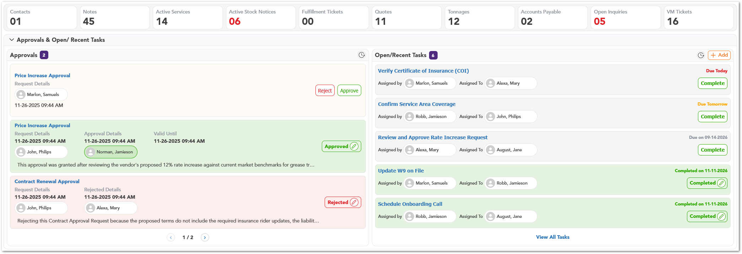
The Dates, Documents & Contacts section groups important provider reference information in one area. It displays key provider dates, related documents, and associated contacts, allowing users to review compliance dates, access uploaded files, and confirm contact details directly from the provider overview.
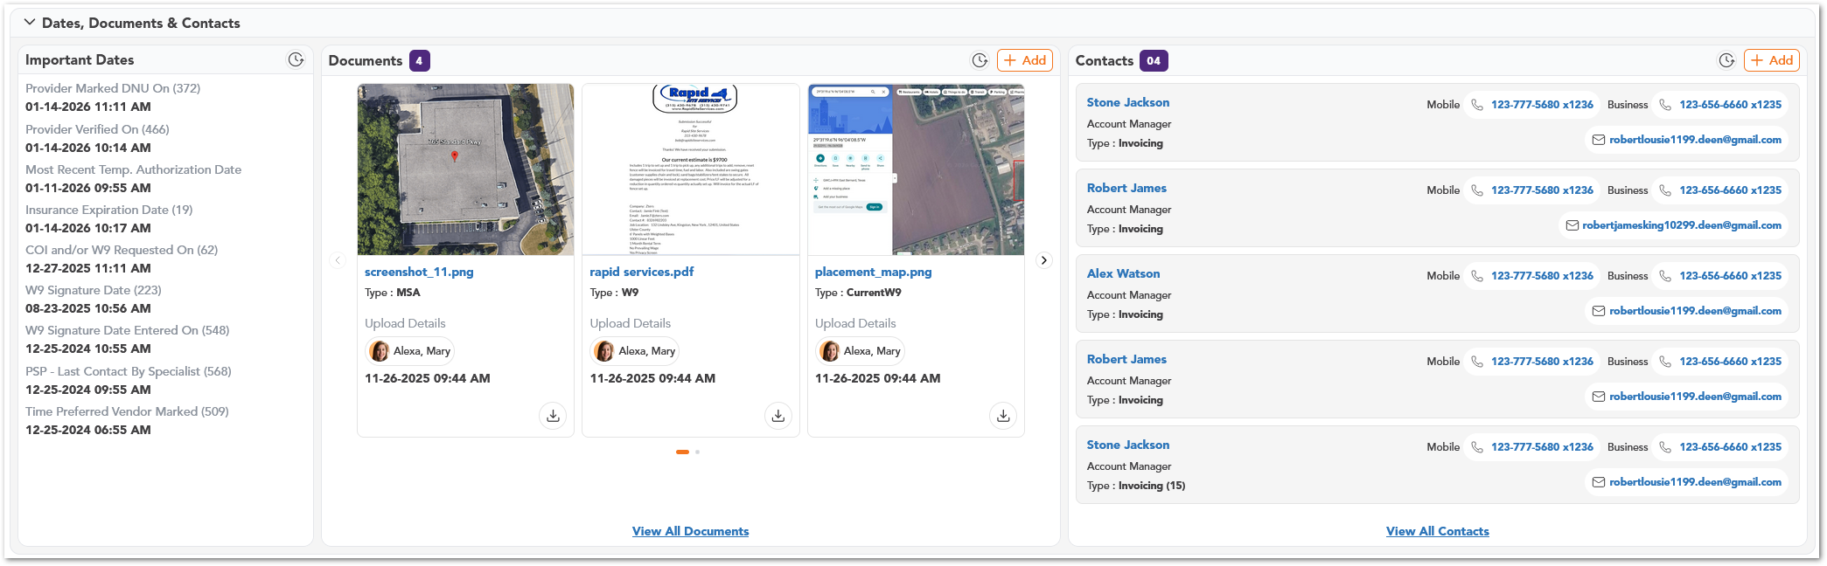
The Services & Activity Timeline section shows the provider’s service activity and recent record history. The Main Information area summarizes service counts by product type, while the Activity Timeline displays recent updates, changes, uploads, verification events, and onboarding activity in chronological order.
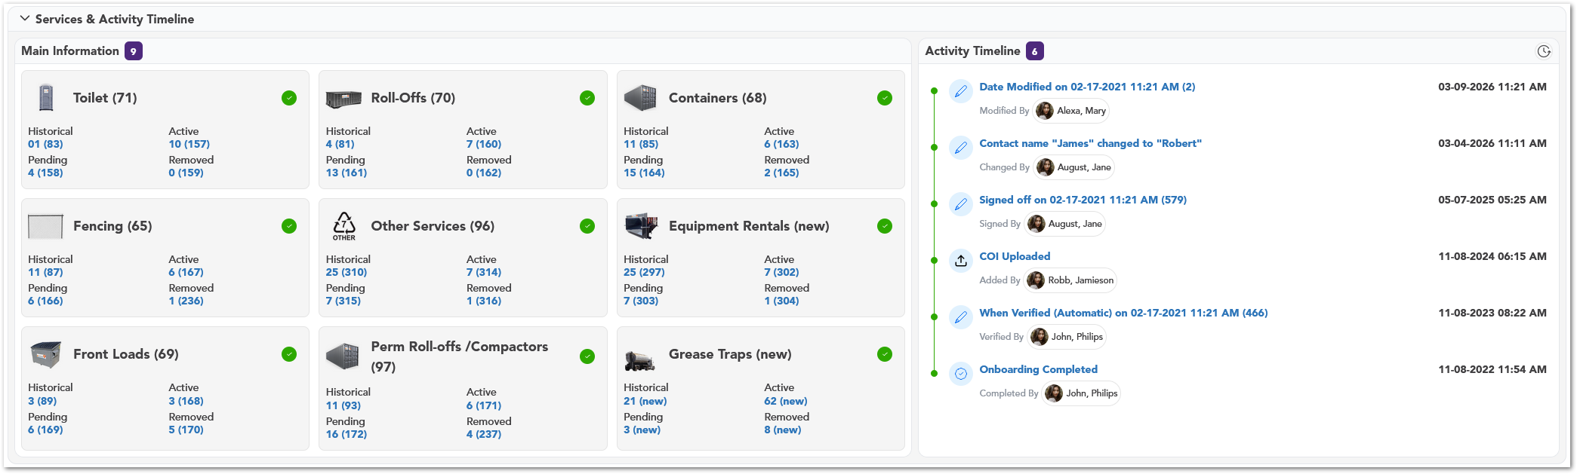

Notes
The Notes section displays notes associated with the selected service provider. Notes are organized in a table and may be grouped by note type, such as Service Provider Notes or Required Fencing Notes. Users can search for specific notes, sort or filter the table columns, and review details such as the record owner, date modified, note type, and note content.
Each note row includes available actions for managing or viewing the note record. This section helps users review provider-related comments, reminders, operational instructions, and important service details without leaving the service provider record.
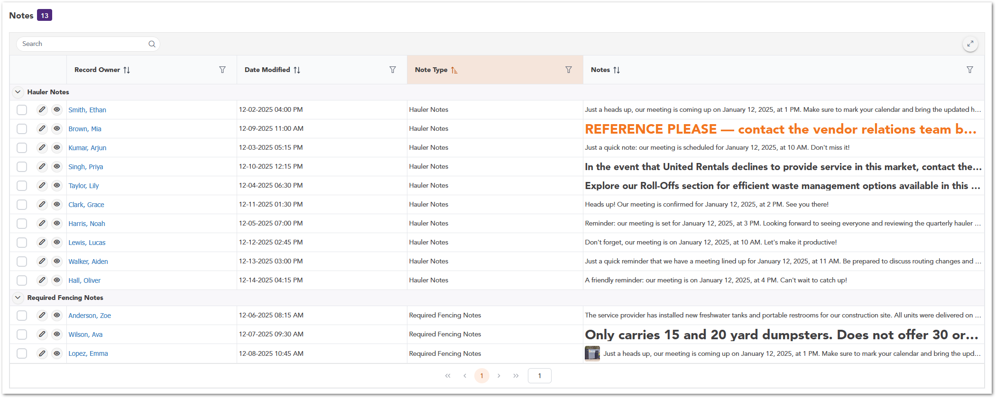

Service Provider Contacts
This module manages contact information for service providers and their representatives. It ensures proper communication channels are maintained. Contacts are linked to specific providers.

Fulfillment Tickets
This module manages tickets related to service fulfillment and execution. It allows users to track delivery, scheduling, and completion of services. It ensures customer requests are properly executed.

SPM Tickets
This module manages Service Provider management tickets used for coordination with service providers. It supports tracking communication and resolving operational issues. It helps align Service Provider-related workflows.

Pricing Zones
This module defines geographic or operational zones used for pricing calculations. It allows users to organize areas based on service coverage. It supports location-based pricing strategies.

Pricings
This module manages pricing structures, rates, and rules for services and products. It allows users to configure how pricing is applied. It supports flexible and accurate pricing management.

Service Provider Quotes
This module manages quotes submitted by service providers for service requests. It allows users to review and compare Service Provider pricing. It supports decision-making in service procurement.

SPM Activities
This module tracks activities related to Service Provider management operations. It provides visibility into interactions and updates with service providers. It supports monitoring of Service Provider workflows.

Price Increases
This module manages updates and adjustments to pricing. It allows users to track and apply approved price changes. It supports financial control and transparency.

Out of Stock
This module tracks products or services that are currently unavailable. It provides visibility into stock limitations. It supports operational planning and service availability.

Zip Codes
This module manages geographic areas where services are available. It allows users to associate locations with providers and pricing. It supports accurate service coverage configuration.

Service Provider Ratings
This module tracks and evaluates service provider performance. It allows users to review ratings and feedback. It supports quality control and Service Provider assessment.

Service Provider Business Hours
This module manages the availability schedules of service providers. It allows users to define working hours and service windows. It supports scheduling and operational planning.

Administratorz section
The Administratorz section provides system configuration and control capabilities. It allows users to define codes, states, and system rules that govern workflows and data structure. This area supports internal administration, task management, and system customization. It ensures consistency and standardization across the platform.
Note: The Administratorz section is restricted by role-based access and only visible to admin users.

Products
This module manages the zters products and services. It ensures consistency across the system. It supports structured data management.

Product Codes
This module manages standardized codes used to identify products and services. It ensures consistency across the system. It supports structured data management.

Ticket Codes
This module defines codes used to classify and categorize tickets. It helps organize service requests and workflows. It supports better tracking and reporting.

States
This module manages system states used in workflows, such as statuses or process stages. It ensures consistency in process tracking. It supports workflow standardization.

Notes
This module manages internal notes associated with system records. It allows users to add contextual information or comments. It supports collaboration and traceability.

Service Provider Link
This module manages relationships between service providers and system entities. It ensures proper linkage across modules. It supports data consistency and integration.

Tasks
This module manages internal tasks assigned to users. It allows tracking of activities and responsibilities. It supports operational coordination.

Lead Sources
This module manages the origin of leads, such as campaigns or referrals. It helps track how leads are generated. It supports sales analysis and reporting.

Lead Parent
This module manages hierarchical relationships between leads or accounts. It allows linking related entities. It supports better organization of sales data.

Answered Phone Calls
This module tracks and logs phone call interactions. It provides visibility into communication activities. It supports customer interaction tracking.

Userz section
The Userz section is responsible for managing user access and system security. It includes tools for creating users, defining roles, assigning permissions, and organizing groups. This section ensures that users have appropriate access based on their responsibilities. It supports role-based access control and system governance.

Users
This module manages user accounts with access to the platform. It allows creating, editing, and maintaining user information. It supports overall user administration.
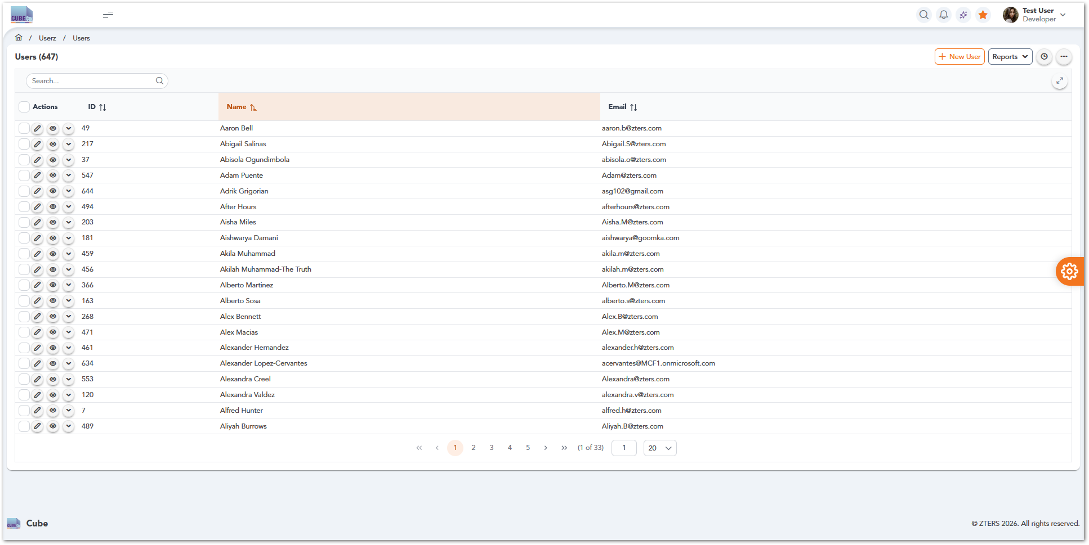

Roles
This module defines roles that determine user responsibilities and access levels. It allows grouping permissions based on job functions. It supports role-based access control.

Permissions
This module manages detailed access rights assigned to roles. It allows controlling what users can view or modify. It ensures system security and proper access control.

Groups
This module organizes users into groups for easier management. It allows assigning roles and permissions at a group level. It simplifies user administration.

Zeepz Section
The Zeepz section focuses on internal engagement and sales pipeline management. It includes tools for managing leads, employees, and recognition programs such as bonus points and badges. Users can track team participation and process reward redemptions. This section supports both operational engagement and sales-related activities.

Leads
This module manages potential customers and sales opportunities. It allows users to track lead information and progression. It supports pipeline management and conversion tracking.

Employees
This module manages internal employee records and related information. It allows users to maintain employee data within the system. It supports internal administration and tracking.

Bonus Points
This module manages the internal rewards system used to recognize employee contributions. It allows tracking and assigning points. It supports engagement and recognition initiatives.

Badges
This module manages recognition badges awarded to users. It allows creating and assigning badges based on achievements. It supports gamification and employee engagement.

Reportz section
The Reportz section provides access to data analysis and reporting tools within the platform. It includes predefined, custom, and AI-generated reports, as well as integrations with Power BI dashboards. Users can analyze operational and financial data to support decision-making. This section enables visibility into system performance and business insights.

Static Reports
This module provides access to predefined reports with standard system metrics. It allows users to view consistent and ready-to-use data. It supports routine monitoring and analysis.
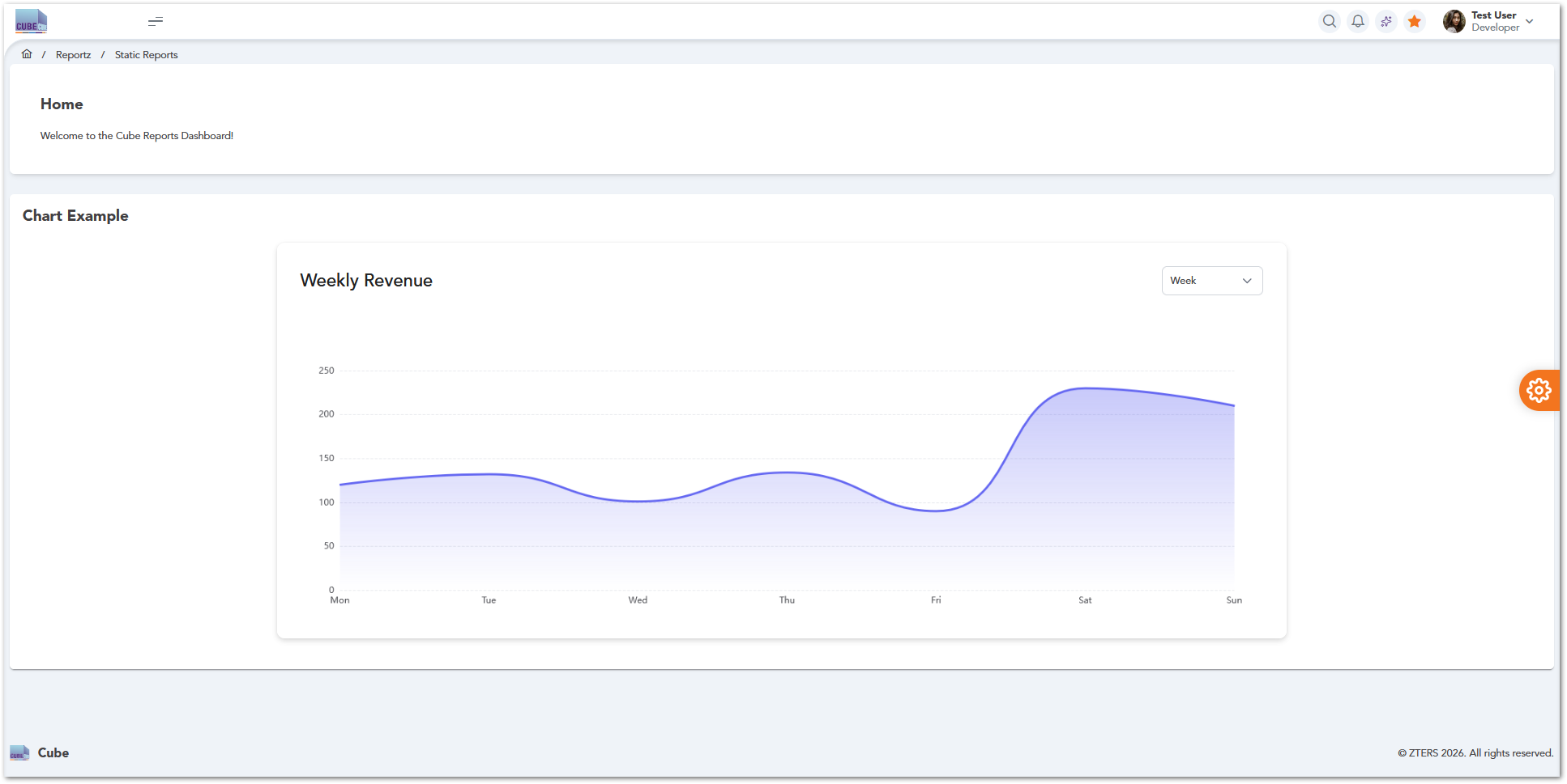

Custom Reports
This module allows users to create reports based on selected data fields and filters. It provides flexibility to generate tailored insights. It supports specific business and operational needs.
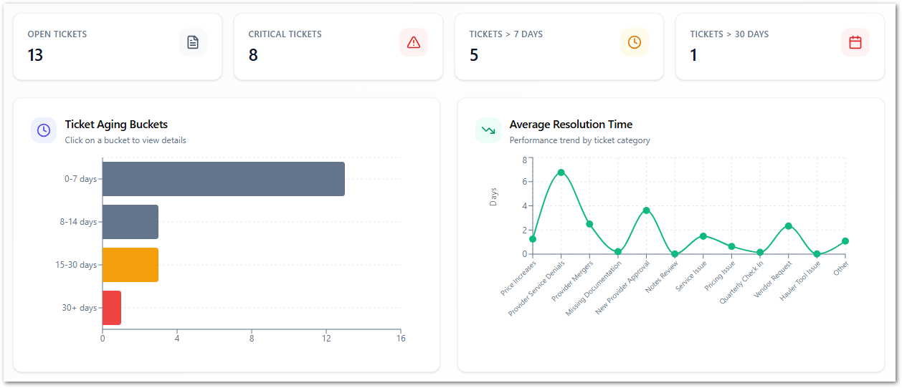

AI Reports
This module generates insights using AI-based analysis of system data. It helps identify trends, patterns, and potential predictions. It supports advanced decision-making.

Power BI Reports
This module provides access to reports integrated with Microsoft Power BI dashboards. It enables advanced data visualization and analytics. It supports business intelligence reporting.

Overall System Functionalities
This section describes common functionalities available across multiple modules within the CUBE platform, such as data filtering, bulk actions, export options, and table interactions. These features provide users with efficient ways to manage and analyze data regardless of the module being used.

Bulk Actions
Users can select multiple service provider records and apply actions to them simultaneously. Steps to Perform Bulk Actions:
- Navigate to Operationz → Service Providers.
- Locate the list of service providers displayed in the table.
- Use the checkboxes in the Actions column to select one or more records.
- To select all records on the page, use the checkbox located in the table header.
- Once records are selected, available bulk actions can be applied (depending on system configuration).
- Confirm the action if prompted.
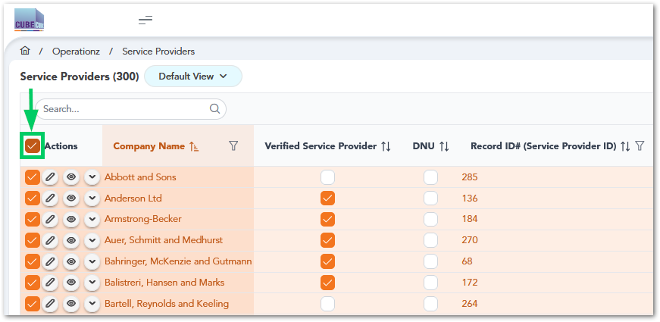

Export and Print Options
Users can export or print service provider data using the options available in the interface:
- Navigate to Operationz → Service Providers.
- Click the three-dot menu (⋯) located in the upper-right corner of the table.
- Select one of the following options:
- View Summary
- Export CSV
- Print
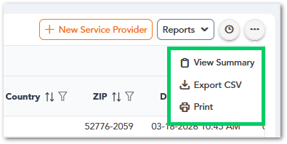

Filtering and Ordering
Ordering (Sort Data)
- Locate the column header (e.g., First Name, Last Name).
- Click the sorting icon (↑↓) next to the column name.
- Click once to sort in ascending order.
- Click again to switch to descending order.
Filtering (Narrow Results)
- Click the filter icon (funnel) next to the column name.
- Enter or select the desired filter criteria.
- Apply the filter to update the table results.
- Clear or reset the filter to return to the full dataset.


Search Bar
- Locate the search bar at the top of the data table.
- Enter a keyword related to the record you want to find (e.g., name, email, ID).
- The system will automatically filter results based on the entered text.
- Modify or clear the search input to update or reset the results.
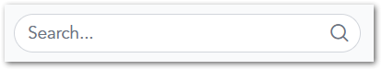

Settings

Header Controls
The Top Navigation Bar is located at the upper-right section of the CUBE interface and provides quick access to commonly used system functions and user-related options. These controls allow users to perform actions such as searching within the system, viewing notifications, accessing system utilities, and managing their user profile.
Icon / Element | Name | Description
 | Search | Allows users to quickly search within the application.
 | Notifications | Displays system alerts, updates, or important notifications.
 | Quick Actions | Provides access to additional system tools or quick actions.
 | Favorites | Allows users to bookmark or access frequently used items.
 | User Profile | Displays the logged-in user information and provides access to account-related options such as profile settings or logout.

Profile
Description of the user profile

Inbox
Description of user inbox

Settings
Description of settings section

User Roles
Role assignation for the application users. It could be presented in a table as follows:
Section | Module | AM | CSS | CWS | SPM | Cube Leads | Cube Admin | PSP Specialist | SPM Specialist | Service Provider Team Lead | Tonnage
Dashboardz | PSP Specialist |  |  |  |  |  |  | 
Dashboardz | Servide Provider Summary
Dashboardz | SPM Specialist
Dashboardz | Service Provider Summary
Dashboardz | Tonnage
Customerz | Customers
Customerz | Customer Contacts
Customerz | Sites
Customerz | Reviews
Customerz | CC Transactions
Customerz | Credit Limit Requests
Customerz | Accounting Inquiries
Customerz | Billing Preferences
Salez | Products
Salez | Service Tickets
Salez | Line Items
Salez | Invoices
Salez | AP Hub
Salez | Pricing History
Salez | Z Sight Monitors
Salez | Assets
Operationz | Service Providers
Operationz | Service Provider Contacts
Operationz | Fulfillment Tickets
Operationz | SPM Tickets
Operationz | Pricing Zones
Operationz | Pricings
Operationz | Service Provider Quotes
Operationz | SPM Activities
Operationz | Price Increases
Operationz | Out of Stock
Operationz | Zip Codes
Operationz | Service Provider Ratings
Operationz | Service Provider Business Hours
Zeepz | Leads
Zeepz | Employees
Zeepz | Bonus Points
Zeepz | Badges
Administratorz | Products
Administratorz | Product Codes
Administratorz | Ticket Codes
Administratorz | States
Administratorz | (Combined) Notes
Administratorz | Service Provider Link
Administratorz | Tasks
Administratorz | Lead Sources
Administratorz | Lead Parent
Administratorz | Answered Phone Calls
Userz | Users
Userz | Roles
Userz | Permissions
Userz | Groups
Reportz | Static Reports
Reportz | Custom Reports
Reportz | AI Reports
Reportz | Power BI Reports

Note: This section is mandatory for all applications with role-based access.

WORKING PROCEDURES
Workflows (including diagrams if applicable) for different options within the application.

Account Manager Working Procedures

Create and Manage a Customer Record

Purpose
This procedure describes how an Account Manager creates, searches, and manages customer records within the CUBE platform. Customer records store key information required for service delivery, billing, and operational activities.

Roles and Responsibilities
Role | Responsibility
Account Manager | Creates and manages customer records
Cube Admin | Maintains system configuration and user access if required

Preconditions
- The user must be logged into the CUBE platform.
- The user must have an Account Manager or Cube Admin role.
- The user must have access to Customerz → Customers.
- Required customer information must be available (name, contact details, company).

Process Diagram
Warning: Pending Diagram

Procedure Steps
Create a New Customer
- Navigate to Customerz → Customers.
- Click the New Customer button.
- Enter the required customer information (e.g., name, email, phone, company).
- Review the entered information.
- Click Save to create the record.
- Verify the customer appears in the customer list.
Search and Filter Customers
- Use the Search bar to locate specific customer records.
- Use column filters to refine results (e.g., name, email, company).
- Sort columns as needed to organize the data.
Manage Existing Customers
- Locate the customer in the table.
- Use the Actions column to:
- View details
- Edit the record
- Perform additional actions (if available)
- Save any updates made to the customer record.

System Behavior
Action | System Behavior
User opens Customers module | The system retrieves and displays a list of customer records.
User performs search/filter | The system dynamically updates the table based on criteria.
User creates a customer | The system validates input and stores the record in the database.
User updates a record | The system saves changes and refreshes the table view.

Results
- A new customer record is created and stored in the system.
- Customer information is available for linking to sites, services, and billing.
- Updated records are reflected immediately in the customer list.

Exceptions / Error Handling
Please refer to the troubleshooting section in BookStack.

Manage Service Sites

Purpose
This procedure describes how an Account Manager creates, searches, and manages service site records within the CUBE platform. Service sites represent physical locations where services are delivered.

Roles and Responsibilities
Role | Responsibility
Account Manager | Creates and manages service site records associated with customers
Cube Admin | Maintains system configuration and access permissions if necessary

Preconditions
- The user must be logged into the CUBE platform.
- The user must have an Account Manager or Cube Admin role.
- A customer record must already exist.
- The user must have access to Customerz → Sites.
- Required site information must be available (site name, location, associated customer).

Process Diagram
Warning: Pending Diagram

Procedure Steps
Create a New Site
- Navigate to Customerz → Sites.
- Click the New Site button.
- Enter required site information (site name, location, associated customer).
- Review the entered data.
- Click Save to create the site record.
- Verify the site appears in the list.
Search and Filter Sites
- Use the Search bar to locate specific site records.
- Apply filters based on location, customer, or other available fields.
- Sort columns to organize site information.
Manage Existing Sites
- Locate the site in the table.
- Use the Actions column to:
- View details
- Edit site information
- Perform additional actions (if available)
- Save updates to the site record.

System Behavior
Action | System Behavior
User opens Sites module | The system retrieves and displays site records.
User searches or filters | The system updates the table dynamically.
User creates a site | The system validates data and stores the record.
User updates a site | The system saves changes and refreshes the list.

Results
- A new service site is created and linked to a customer.
- Site records are available for service assignment and operations.
- Updates are reflected immediately in the system.

Exceptions / Erro Handling
Please refer to the troubleshooting section in BookStack.

Customer Success Specialist Working Procedures

Admin Working Procedures

APPROVAL SIGNATURES
Digital signature blocks below are formatted for DocuSign / Adobe Sign.
Name | Role | Digital Signature Block | Date (dd/mm/aa)
Anthony Bures | Digital Development Manager |  | 25/06/2026

--- END OF THE DOCUMENT ---

